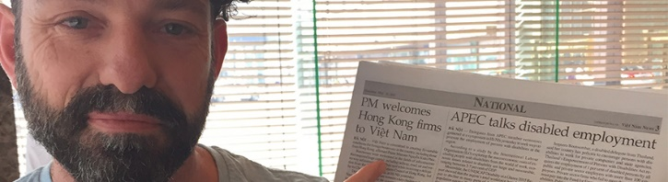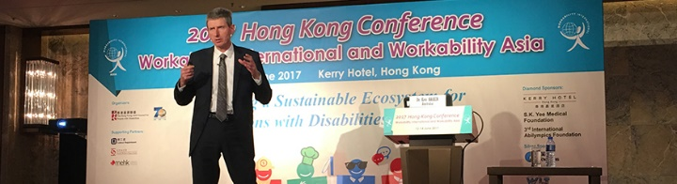

International exposure for Ticket to Work
National Disability Services (NDS) recently presented at two International Conferences Ticket to Work and how improving outcomes for people with disability through the Vocational Education and Training system can lead to work opportunities.
Workability International: Hong Kong
Ken Baker and Kerrie Langford from NDS presented at the Workability International Conference, held in Hong Kong in June 2017.
Over 400 people representing 20 counties attended the conference, hosted by Hong Kong Joint Council for People with Disabilities and Hong Kong Council of Social Service.
"They wanted to have some innovation streams," said Kerrie of the conference.
"What we put forward with Ticket to Work was, 'This is something we've been doing in Australia. It's new, it's innovative…' We explained that we used some of the learnings we gathered internationally to develop it. We researched other countries, particularly the United States, the UK and Canada."
"At the conference, we were talking about where we’re at with Ticket to Work, which is essentially about the early engagement of young people while they're still at school. In Australia, that's actually quite new – It's not funded at this point in time. So, we were highlighting our great outcomes and our networks," said Kerrie.
Asia-Pacific Economic Cooperation (APEC) Symposium: Hanoi, Vietnam
NDS Tasmanian State Manager David Clements presented in Hanoi, Vietnam at the Asia-Pacific Economic Cooperation (APEC) Symposium on Promoting Employment of Persons with Disability.
The Symposium brought people together from across the APEC economies to consider a draft report and share their experiences to establish best practices that could be adopted across the APEC community of economies.
David’s presentation focused on how improving outcomes for people with disability through the Vocational Education and Training system can lead to work opportunities. He discussed the importance of legislative and regulatory frameworks such as the Disability Discrimination Act (1992) and related Education Standards to policy and programs that inform practical activity on the ground.
David described how the National Disability Coordination Office (NDCO) program and Disability Employment Services (DES) providers are supporting the activities of NDS’s Ticket to Work. The audience showed great interest in how Australia has achieved practical outcomes through these programs.
Contact information
Michelle Wakeford, National Manager Ticket to Work, 0413 750 745 michelle@tickettowork.org.au

