# The changing world of work and young people with disability

The changing world of work will benefit people with disability if given the right supports including skill development, career education and pathway planning.

PricewaterhouseCoopers Australia (PwC) suggest that 44% or 5.1 million current Australian jobs are at risk of digital disruption in 20 years and 75% of the fastest growing occupations require STEM skills.[1]

Leading economists PwC suggests that, “We are at a critical point in time. Australia needs to foster a nation of innovation to ensure our children, businesses and economy prosper in the long term. We need to equip our children with 21st century skills, to enable them to think, solve, create, persist, sort and share. Above all, we need to encourage them to remain curious, imaginative and passionate. [2]

There has been an increase in non-standard or alternative working arrangements such as self-employment, temporary/agency work, seasonal work, independent contracting, fixed-term contracts and on-call work (FYA 2014). The Business Council of Australia (2012) predicts that alternative working arrangements will become more important in the future.

## Potential benefits for young people with disability

The changing world of work will benefit people with disability if given the right supports and opportunities for a range of reasons including:

* Increase in self-employment and micro businesses; People with disability are significantly under-represented in labour market yet ABS data finds that People with a disability are more likely to run a business than those without a disability. (11.6 per cent and 8.2 per cent respectively)
* Research shows the characteristics inherent in those with disabilities are well suited to entrepreneurship. These include creative problem-solving skills, flexibility, grace under pressure, persistence, a sense of humour, willingness to ask for help, resilience and resourcefulness. [3]
* Gig economy will suit many people with disability as they have often have strong skills in certain tasks or area. Therefore people with disability are able to focus on their strengths, where as traditional jobs have a range of tasks, which can disadvantage some people with disability in accessing those roles.[4]
* The traditional mechanism of hiring (application and interview) are becoming less prevalent in the new market, therefore bypassing real or perceived job discrimination in application process for people with disability.
* The rise in gig economy will benefit people with episodic disabilities.
* The rise of technology advances and innovation has made a huge difference for people with disability in the workforce. Every week new assistive technology is being developed that can assist people participate in the labour force and community.
* The rise of the virtual employment will assist people with disability that need or want to work from home.
* There has been a rise of ‘business within a business’ that has opportunity to benefit people with disability.

## What we can do

There is much we can do in career development to build on in this area and prepare and give students with disability the opportunity to thrive in the changing world of work.

Young people with disabilities are an untapped resource in a tight labour market. There is a critical need for a holistic approach when considering the career planning for young people with disabilities. In particular, influences and networks in the individual’s life have an effective role to plan in securing successful transitions. [5]

Career Education that prepares young people with disabilities to aspire and achieve their career goals needs to:

* Be responsive to the unique aspirations and developmental needs of each young person
* Encourage and equip young people to be self–managing and self-determining individuals
* Build enterprising skills in young people with disability.
* Assist and support students to locate and arrange suitable work experience activities
* Actively create, expand and engage the support networks of young people
* Make career information available in a format that is easily accessible to young people with a disability
* Develop strong working relationships with other relevant agencies and service provider
* Provide organisational support for the delivery of effective career development programs and services[6]

## Ticket to Work

Ticket to work has been doing a range of activities to support young people with disability be ready for the new world order**: $20 boss project**

Ticket to Work sites have been working with specialist schools to adapt material in the $20 boss project for students with intellectual disability. The aim is to ensure they are equipped with enterprise skills that will support them into the future.[7]

### Microbusiness training

Running training for Ticket to Work members and NDIS providers on micro-business development for people with disability. The training is run by Renae Hartman of Your Way Business Consulting. [8] [9]

### Microbusiness development for young people with disability

As part of our work in WA and the After School Jobs pilot, we supporting students who want to set up a small business while at school. To date the Ticket to Work network have supported 20 young people to set up their own business. Below are some stories.

We need to ensure all young people are prepared for the new world of work, but particularly young people with disability as they traditionally have had difficulty accessing the traditional labour market. Indeed young people with disability are set to thrive in the new work order if given opportunity to develop enterprise skills, get the right supports at the right time including career education and pathway planning.

**Contact:** Michelle Wakeford. Ph: 0413 750 745 Email: [michelle@tickettowork.org.au](mailto:michelle@tickettowork.org.au)

**tickettowork.org.au**Matt Simson and his repairs microbusiness

Matt Simson has a passion for tinkering with engines and bringing new life to old machines. Matt has been repairing garden equipment and small motors since he left school. To learn more about engines Matt did the Certificate in Small Engines course at Chisholm Institute in 2012. With a qualification in hand, Matt has since up his own small engines repairs business. Matt renews lawn mowers, chain saws and anything else he can get his hands on, he then sells them on. People will also bring them their machines that are broken and Matt will repair them for a fee.

Matt turned his passion into a business because “I love fixing them and it makes me happy seeing these machines working after working on them”

“I want to be my own boss and to show people that even if you’ve got a disability you can still make something important out of your life”. Matt says.

Matt dreams are to see his business grow bigger. He recently attended some Micro-enterprise training at the National Disability Services (run by Ticket to Work). Matt said “the training was really helpful and gave me lots of knowledge to work on my business and make it better”.

As well as fixing small engine, matt has a passion for riding BMX and repairing bikes – he even has his own YouTube channel where he promotes his bikes and riding skills!

Matt is working on ways to promote his business and is open for new clients – so if you or someone you know has a small engine to repair (or bike) please get in touch with him directly on 0411 770 563.

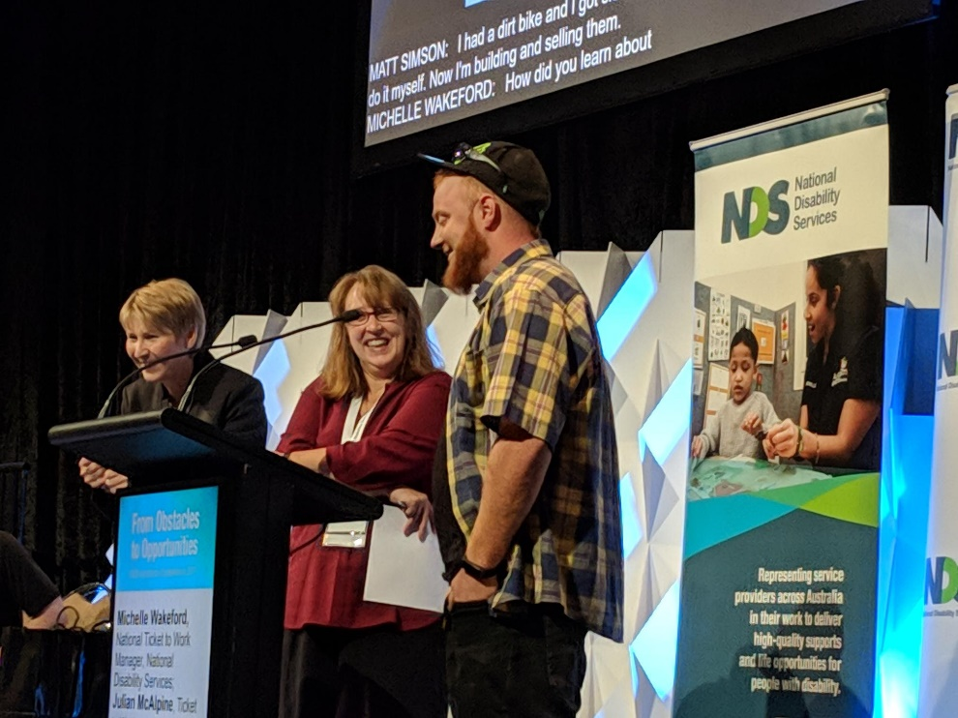

### Kyal Chamberlain and his dog biscuit microbusiness

Kyal Chamberlain is a 16 year old student with autism and ADHD. He lives at home with his parents, sister, brother and family dog Apollo.

Kyal participated in the NDIA School to Work transition pilot in Western Australia through Rocky Bay disability service. Rocky Bay staff were trained and mentored in the use of customised employment techniques through the Ticket to Work network coordinator.

Alison, Anna and Kirstie from Rocky Bay worked with Kyal through the Discovery process. During this phase, it was determined that Kyal prefers hands-on practical activities.   They supported him to explore his love of cooking, which Kyal has embraced, regularly cooking delicious meals for the family. Kyal was keen to combine his interest for cooking and his love of animals.

Kyal felt that Apollo, the family husky, deserved some healthy home-made treats, after doing online research on recipes, his first batch of cookies was a huge success. As Apollo firmly chose Kyal’s home made biscuit over a commercial treat. Anna offered to find a café that would be prepared to trial Kyal’s dog biscuits with their customers.

Steve, owner of Bolt Coffee (a dog friendly café) was approached and was happy to give Kyal’s biscuits a one week trial. Kyal delivered a sample batch, accompanied by his Mum and Anna. It was a successful trial as every single biscuit was sold and Steve ordered a further 60 packets of biscuits. Bolt Coffee is now a regular customer placing a regular weekly order. In addition, there has been a boost in sales.  The family’s dog groomer has made more orders since ordering their first batch.

Kyal has set up a Facebook page, for his new business, Doggy Delight @kyalsDoggyDelights. Kyal is currently producing about 400 biscuits a week, all made by hand.

Kyal continually modifies his recipe, so that he gets the best possible taste and texture for his canine customers. He currently produces two varieties, chicken and beef, and will soon be branching out to include peanut butter into his recipe, as well as a lactose free variety, and smaller biscuits for the more petite dog.

The business is a family affair, Kyal’s twin brother Benji has designed the labels. Kyal’s mum, Amanda-Jane, states “I am so proud of Kyal and this has finally made him feel worthwhile and shows he can achieve something with his disability. Kyal’s confidence has gone through the roof”.

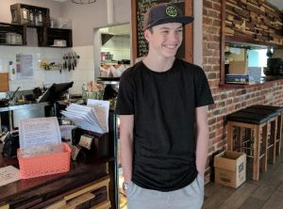

1. PricewaterhouseCoopers Australia 2015, *A smart move: future-proofing Australia’s workforce by growing skills in science, technology, engineering and maths (STEM)*, PricewaterhouseCoopers Australia, [Sydney], <http://www.pwc.com.au/pdf/a-smart-move-pwc-stem-report-april-2015.pdf>.
2. Source: https://www.pwc.com.au/stem.html
3. Maritz, A, Laferriere, R 2016, 'Entrepreneurship and self-employment for people with disabilities', *Australian Journal of Career Development*, vol.25, no.2, pp.45-54.
4. <https://www.smh.com.au/business/small-business/disability-doesnt-mean-entrepreneurial-inability-20160706-gpzrfm.html>
5. State of Victoria (Department of Education and Training) 2017, The Strengthened Career Education Guide for Teachers and Career Practitioners guide supporting students with disability to explore, plan and navigate pathways during and after their journey at school.
6. Miles Morgan Australia 2012, *Effective career development services for young people (15-24) with disability*, CICA, Melbourne<http://www.tickettowork.org.au/wp-content/uploads/2014/05/Facilitating-the-Career-Development-of-Young-People-with-Disability.pdf>.
7. https://www.fya.org.au/resource-library/
8. https://www.facebook.com/yourwaybusinessconsulting/
9. https://micro-enterprise.valuedlives.org.au/