National Disability Services Ticket to Work Submission to the Inquiry into access to TAFE for learners with disability

About National Disability Services
National Disability Services (NDS) is the peak industry body for non-government disability services. It represents service providers across Australia in their work to deliver high-quality supports and life opportunities for people with disability. Its Australia-wide membership includes over 1,180 non-government organisations, which support people with all forms of disability. Its members collectively provide the full range of disability services - from accommodation support, respite and therapy to community access and employment. NDS provides information and networking opportunities to its members and policy advice to State, Territory and Federal governments.
Recommendations of this submission
- Work based learning encompassing both formal qualifications and work experience needs to be supported as a strategy for people with disability gaining access to employment

- Traineeship and Apprenticeships including School Based Apprenticeships and Traineeships are a proven example of work based learning which could be adapted to meet the needs of a broader cohort of people with disability

- Young people with disability need access and support to complete the higher level TAFE courses which lead to employment outcomes

- Application of the Ticket to Work model with its emphasis on cross sector collaboration could support these outcomes by supporting TAFE providers, employers and other stakeholder work together

Introduction
NDS welcomes the opportunity to provide this submission to the Legislative Assembly Economy and Infrastructure Committee’s Inquiry into access to TAFE for learners with disability.
NDS Ticket to Work is a national initiative of National Disability Services (NDS) which focuses on improving school to work pathways for young people with significant disability as defined by the Department of Social Services (2020). Consequently, this submission will focus upon the experience of assisting students with disability in transitioning from secondary school to open employment and the role of TAFE.
Research shows in Australia young people with significant disability are not transitioning successfully from school into further training or employment; which is a factor often contributing to life-long disadvantage. This group of young people are more likely to drop out of school early, be excluded from the labour force, have fewer educational qualifications, experience poverty and be socially isolated. It is imperative that these trends are reversed: The findings of research by Siperstein, Parker and Drascher (2013) indicate if young people with significant disability do not engage in mainstream employment by age 21, it is unlikely that they ever will.
Young people with disability often face a pervasive culture of low expectations resulting in a lack of opportunities for genuine sustainable employment. Prolonged exposure to ‘horizon-limiting views and experiences’ may see these beliefs become internalised and their capacity to recognise their potential diminishes (PricewaterhouseCoopers Australia, 2011). Along with the young people not being able to identify their potential, parents also lose the ability to see their child’s potential and, consequently, cannot support them to achieve their goals. Expectations of parents are critical in the success of transition from school to work for young people with disability (Carter, Austin, & Trainor, 2012; Gilson, Carter, Bumble, & McMillan, 2018). According to the Executive Summary of Victorian Equal Opportunity and Human Rights Commission (2012) ”…a poor education is one of the key reasons why the economic and social participation rate of people with disabilities is so low.’
Victorian TAFE funding needs to be modified to better support young people with disability to gain employment through education and training, which is critical to improving social and economic outcomes for people with disability. The NDS Ticket to Work initiative focuses on improving school to work pathways for young people with disability through a coordinated approach. This initiative advocates for systemic change and works to improve open employment participation in Australia by working collectively at a local level and providing an architecture for optimal employment and career achievement for young people with disability. This submission is informed by the experience, research and evaluations of Ticket to Work.
We believe Ticket to Work holds key insights for the Committee’s Inquiry into access to TAFE for learners with disability.

The impact of VET participation upon young people with disability
Multiple sources indicate access to the open employment market is problematic for young people with disability in Australia. Strenuous efforts have gone into the development of public policy to increase their social and economic participation without success. However, participation in Vocational Education and Training, (VET) of which the TAFE is a significant provider in Victoria, is a proven method of enhancing their employment opportunities.
Amongst the key findings of Polidano and Mavromaras (2010), VET completion significantly improves the likelihood of young people with disability both obtaining and retaining employment. These authors claim unemployed people with disability increase their likelihood of obtaining employment from 9% to 29% upon completion of a VET Certificate III level or above course. In comparison, those unemployed without a disability, completion of comparable training increases their likelihood of employment from 52% to 62%.
Work based learning encompassing both formal qualifications and work experience is a beneficial strategy for people with disability gaining access to employment (Lewis, Thoresen, & Cocks, 2011a, 2011b). A three year longitudinal study undertaken by Thoresen, Cocks, and Parsons (2019) demonstrates substantial benefits of VET traineeships and apprenticeships. These researchers found over time the gap in outcomes reduced between graduates with and without disabilities. Apprenticeship and traineeship graduates with disability experienced improved employment and related outcomes such as income and hours of work.

The low participation of people with disability in VET
Despite these clear benefits from participation in VET, people with disability have low rates of participation; only 4% in 2008 (McVicar & Tabasso, 2016). Cavallaro, Foley, Saunders, and Bowman (2005) found this cohort of students are more likely to undertake Cert I or II level courses and not go on to the higher qualifications that are more likely to lead to employment outcomes (Karmel, 2019). The measurement of completion rates is complex and depends upon a range of variables which include the type of disability and intersects with other variables such as low socioeconomic status (McVicar & Tabasso, 2016). Karmel (2019) indicates the overall data shows low completion rates and questionable employment outcomes for those completing these courses, including students with disability.
McVicar and Tabasso (2016) highlight two gaps for disadvantaged students, including those with disability. The first is in VET completion rates and the second is in labour market outcomes. They identify completion rates in VET are low but are even lower for disadvantaged students. In a summary of McVicar and Tabasso’s findings, Buddelmeyer and Polidano (2016) noted:
Arguably, the most important finding from the study was that the completion gaps between disadvantaged and non-disadvantaged students only explain a very small part of the post-training employment gaps. McVicar and Tabasso instead find that post-training employment gaps are explained more by differences in observed student characteristics, particularly the lower engagement in work prior to study by disadvantaged students. These results suggest that improving the completion rates among disadvantaged students is not likely to bridge the employment gaps that appear soon after completion and that efforts may be better directed at early career preparation (p. 6).
These authors call for policy interventions that support, ‘… the course choices of people from disadvantaged backgrounds, such as career counselling and the provision of labour market information, may help to close the gap in post-study employment (McVicar & Tabasso, 2016 p. 9).’ Consequently, improving completion rates alone is unlikely to improve employment outcomes. Instead early intervention and career guidance prior to VET participation, ideally during secondary schooling may reduce completion and employment gaps.

The Ticket to Work model
The Ticket to Work Initiative was established in response to poor and falling school to work transitions for young Australians with disability. The Initiative is based on the need to prepare young people with disability during secondary school for VET and employment, similar to the thinking of McVicar and Tabasso (2016).
In the Ticket to Work model, community networks develop and leverage the power of cross-sectoral partnerships to provide individualised support. These networks facilitate the blending of existing resources provide coordination and scaffolding of the relevant employment supports for young people with disability. Participants are on the Department of Education and Training Victoria Program for Students with Disability (PSD) and the majority have a cognitive disability.
A local intermediary undertakes the coordination of networks, supporting the development of truly local community partnerships. The network partners include schools, families, employment services, training organisations, post school providers, NDIS supports and employers.
Specifically, the Ticket to Work model:
- brings together disability-specific and mainstream representatives from a variety of sectors to work strategically and collaboratively
- supports young people to gain access to early experiences that positively influence their views of themselves as workers
- prepares young people with disability for the workplace and gives them an employment pathway that is typical of other young adults
- meets the needs of employers, with enhanced staff retention and profitability for employers

Ticket to Work outcomes
Ticket to Work’s connected approach (34 local networks; 205 schools; 145 local organisations; 2,436 employers) has delivered 1,649 jobs for students with disability. Recent evaluations of elements of the Ticket to Work model indicate:
- The Ticket to Work model has a number of social and fiscal benefits. (See SVA 2020
• Ticket to Work participants post-school are substantially more likely than a similar comparison group to:
  - work in open employment
  - complete year 12
  - participate in the labour force
  - be involved in community and social activities (ARTD 2019)
• Ticket to Work’s approach is working for key stakeholders according to an evaluation involving employers, parents and network members and is in line with international good practice and research (Wakeford, 2019, Kellock 2020, ARTD 2018).
- There is a need to focus on how the different sectors working can work in concert to improve employment outcomes and raise expectations for young people with disability (Meadows, 2020).
- Ticket to Work assists with the effective integration of mainstream and disability support, and it has been shown this approach reduces duplication (ARTD, 2019).
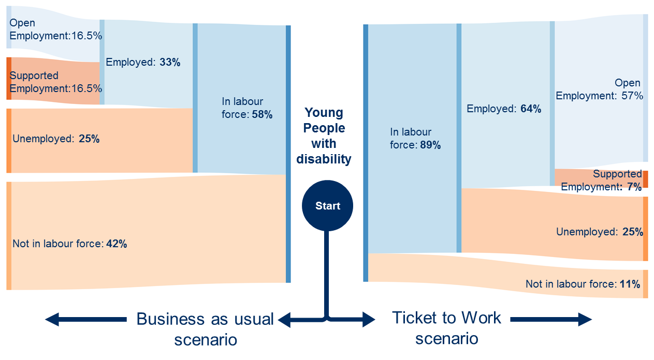
Figure 1 indicates the findings of a comparison study. Ticket to Work participants showed improved outcomes compared to young people that did not have Ticket to Work support (Business as usual)
Ticket to Work participants are:
- Nearly 50 % more likely to complete year 12
- More likely to be studying post school (31% to 23 %)
- Much more likely to have obtained further qualifications (32% to 15%)
- Over three times more likely to be in open employment
- Experience higher levels of social activities.

Conclusion
While not under-estimating the challenges, Ticket to Work has demonstrated in significant numbers of young people can thrive in open employment when prepared and supported while at school through a coordinated approach. Many young people in Ticket to Work participate in School Based Apprenticeships or Traineeships (SBATs). SBATs offers students the option of combining a senior secondary program with part-time employment and is a clear example of work based learning effective for young people with disability.
Work based learning is a critical component of both Ticket to Work and VET which Thoresen et al. (2019) argued will lead to greater employment outcomes for young people with disability. Consequently, there are tremendous opportunities for greater collaboration and learning between VET and Ticket to Work which will enhance employment opportunities for people with disability.
The Ticket to Work model is tested and its success verified. It represents a relatively simple and highly cost-effective means of significantly increasing the numbers of young Australians with disability in open employment.
An assessment of Ticket to Work also found significant savings to government based on the financial value of the fiscal and social impacts of the Ticket to Work outcomes. (SVA: 2019)

Recommendations
- Work based learning encompassing both formal qualifications and work experience needs to be supported as a strategy for people with disability gaining access to employment
- Traineeship and Apprenticeships including School Based Apprenticeships and Traineeships are a proven example of work based learning which could be adapted to meet the needs of a broader cohort of people with disability
- Young people with disability need access and support to complete the higher level TAFE courses which lead to employment outcomes
- Application of the Ticket to Work model with its emphasis on cross sector collaboration could support these outcomes by supporting TAFE providers, employers and other stakeholder work together

Sarah Fordyce Michelle Wakeford,
State Manager (Acting), VIC National Ticket to Work Manager
Sarah.Fordyce@nds.org.au Michelle@tickettowork.org.au
Mob: 0447 441 505 Mob: 0413 750 745
We would welcome the opportunity to discuss our findings in more detail and to answer any questions please contact Michelle Wakeford, National Ticket to Work Manager.
14 October 2020

Ticket to Work evidence
We have commissioned and conducted a significant amount of research/evaluation evidenced based school to work transition for young people with disability.
Atkinson, G., Christian, F., Cassidy, J., Rutherford, J., & Hawkins, A. (2020). Ticket to Work Post School Outcomes Report for National Disability Services Final Report Sydney. Ticket to Work research post school outcomes.
ARTD Consultants. (2019). Ticket to Work Network Analysis. (Sydney). Ticket to Work research article network
ARTD Consultants (2019) Stakeholder report. (Sydney)
Hawkins, A., & Rasheed, E. (2016). Ticket to Work pilot outcomes study: a quasi-experimental evaluation of pathways from school to economic and social inclusion. (Sydney). Ticket to work research pilot outcomes study
Kellock, P (2020) Employer Experience of employing young people with Intellectual/Cognitive disability (Melbourne) Ticket to Work research article employer experience hiring youing people
Meadows, D (2019) Collaboration in school to work transition, (Melbourne) Ticket to Work collobration in school towork transition
Thiele, R., Bigby, C., & Tideman, M. (2018). Young people with intellectual disabilities and work in after school jobs: a literature review. Bundoora, Vic. Retrieved from Latrobe University
Sheppard, L., Harrington, R. & Howard, K. (2017). Leaving School and Getting a Job. Research to Action Guide, A guide for young people with disability who want to work. NDS CADR (Sydney) CADR research to action guides school to employment transitions
Social Ventures Australia Consulting (2020) Ticket to Work Valuation of key outcomes (Melbourne) unpublished at this time.
Wakeford, M, Waugh, F (2014), Transitions to employment of Australian young people with disability and the Ticket to Work initiative, Ticket to Work, (Melbourne).Ticket to Work transitions to employment of Australian young people

References
Buddelmeyer, H., & Polidano, C. (2016). Can VET help create a more inclusive society? Melbourne: Melbourne Institute of Applied Economic and Social Research. Retrieved from Eric.ed. gov.
Carter, E. W., Austin, D., & Trainor, A. A. (2012). Predictors of postschool employment outcomes for young adults with severe disabilities. Journal of disability policy studies, 23(1), 50-63.
Cavallaro, T., Foley, P., Saunders, J., & Bowman, K. (2005). People with a disability in vocational education and training: a statistical compendium. SA: Adelaide, SA: National Centre for Vocational Education Research.
Department of Social Services, Department of Social Services. (2020). Disability Employment Services Eligible School Leaver Guidelines V 1.2. Canberra Retrieved from DSS gov- freedom of information operational information.
Gilson, C. B., Carter, E. W., Bumble, J. L., & McMillan, E. D. (2018). Family perspectives on integrated employment for adults with intellectual and developmental disabilities. Research and Practice for Persons with Severe Disabilities, 43(1), 20-37.
Karmel, T. (2019). Certificates I and II in post-school VET: some preliminary work. Retrieved from Holmesglen media certificates.
Lewis, G., Thoresen, S. H., & Cocks, E. (2011a). Post-course outcomes of apprenticeships and traineeships for people with disability in Western Australia. Journal of Vocational Rehabilitation, 35(2), 107-116. doi:10.3233/JVR-2011-0558
Lewis, G., Thoresen, S. H., & Cocks, E. (2011b). Successful approaches to placing and supporting apprentices and trainees with disability in Australia. Journal of Vocational Rehabilitation, 34(3), 181-189. doi:10.3233/JVR-2011-0546
McVicar, D., & Tabasso, D. (2016). The Impact of Disadvantage on VET Completion and Employment Gaps. Research Report (1925173240). Retrieved from Eric.ed.gov
Polidano, C., & Mavromaras, K. (2010). The Role of Vocational Education and Training in the Labour Market Outcomes of People with Disabilities. (1921413654). Retrieved from ncver.edu.au research
PricewaterhouseCoopers Australia. (2011). Disability expectations: Investing in a better life, a stronger Australia. Retrieved from pwc industry government assets
Thoresen, S. H., Cocks, E., & Parsons, R. (2019). Three Year Longitudinal Study of Graduate Employment Outcomes for Australian Apprentices and Trainees with and without Disabilities. International Journal of Disability, Development and Education, 1-15. doi:10.1080/1034912X.2019.1699648

