The golden rules for effective school to employment transition

- Create an expectation at school, at home and in the community that young people with disability will seek and obtain employment as part of their adult life
- Collaborate locally with other service providers to form partnerships between schools, employment services and disability services
- Enable participation in work experience at multiple time points and provide opportunities for work experience in the same or different areas of work
- Provide collaborative cross-sector opportunities for scaffolded skill development and transfer of skills from one setting to another
- Involve families and local community supports at all levels of discussion about employment and post-school adult life roles
- Start transition planning early
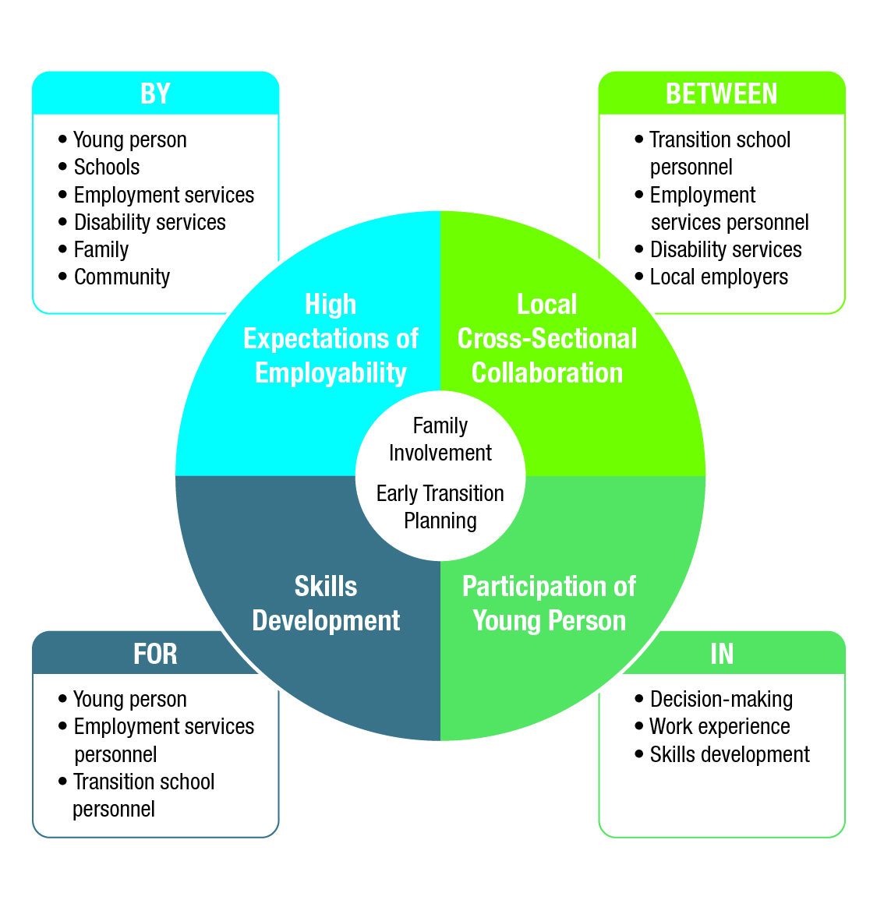
The research informing this poster is available to view in the Research to Action Guide on Effective School to Employment Transitions, available at www.cadr.org.au

