The Centre for Applied Disability Research
The Centre for Applied Disability Research (CADR) is an initiative of National Disability Services (NDS). CADR aims to improve the wellbeing of people living with disability by gathering insights, building understanding, and sharing knowledge. CADR’s applied research agenda is helping to build the evidence base and support stakeholders to better understand what works, for whom, under what circumstances and at what cost.
Research to Action Guides
Bridging the gap between what we know and what we do. Our objective is to build a comprehensive online collection of disability research and translational resources for the Australian context. Our Research to Action Guides are based on the best available local and international evidence and put together by subject matter experts to support research end users to engage with the evidence. We gather and analyse evidence about what works, and package that information into efficient and practical resources.
Acknowledgments
This Guide was authored by Associate Professor Loretta Sheppard, Dr. Rosamund Harrington and Kelly Howard from the School of Allied Health, Occupational Therapy, at Australian Catholic University. This resource was developed with support of Australian governments through the Research and Data Working Group.
NDS Gratefully acknowledges the support of the NSW Government in establishing the NDS Centre for Applied Disability Research.
Suggested Citation
Sheppard, L., Harrington, R. & Howard, K. (2017). Effective school to employment transitions. Research to Action Guide, A Guide for Workers. NDS Centre for Applied Disability Research. Available at www.cadr.org.au
About this Guide
This Research to Action Guide articulates the key components of best practice for supporting the transition from school to employment for young adults with disability in Australia. This Research to Action Guide suite of resources includes a rapid review of relevant literature and three practice guidance resources, targeted at service users, service providers and disability employment practice leaders. The Rapid Review provides a full listing of references informing this Practice Summary. The entire Research to Action Guide is available at the CADR Clearing House, www.cadr.org.au.
Feedback
Do you have feedback, or a suggestion for a Research to Action Guide? We welcome your thoughts and ideas. Please contact info@cadr.org.au.

Effective school to employment transitions:

A guide for workers

Contents
- School to work: what is the problem?
- The six “Golden Rules”
- Supporting young people to think about what they would like to do when they leave school
- The role of supports in school to employment transitions
- Useful links and resources
- Poster for your workspace

1- School to work: what is the problem?
The United Nations Convention on the Rights of Persons with Disabilities 2006 and Convention on the Rights of the Child 1989 recognise that all people with disability have the right to work “on an equal basis with others.” It states that “this includes the right to the opportunity to gain a living by work freely chosen or accepted in a labour market and work environment that is open, inclusive and accessible to persons with disabilities”. Despite these visions, young people with disability continue to face significant barriers to employment in their transition from school in Australia. We need to do better at supporting young people into employment.
The transition from school to young adulthood is a very important time for all young people. Decisions at this time can really impact a young person’s future.

How can this Guide help?
- This guide is about supporting young people with disability on their journey from school to employment
- It will be useful for you if you are an educator, employer, work in an employment service, work as an NDIS planner, Local Area Coordinator, or anyone who supports young people with disability.
- It includes the most important elements of supporting young people to think about work and explore opportunities to gain employment, as identified by the research evidence.
- If you want to know more about the research behind this resource, read the Rapid Review which forms part of this Research to Action Guide.

2 - The six elements to success: the ‘Golden Rules’
Research shows us that there are six elements to supporting the journey to employment for young people with disabilities:
- Expectation
Young people can work
- Collaboration
Different sectors can work together
- Participation
Young people should partake in meaningful work during their school years
- Skills development
Everyone involved in school transitions needs expertise
- Family involvement
Family-centred transitions have better outcomes
- Early transition planning
Early planning impacts outcomes
Figure 1 shows how these elements connect and interact to maximise employment opportunities for young people.
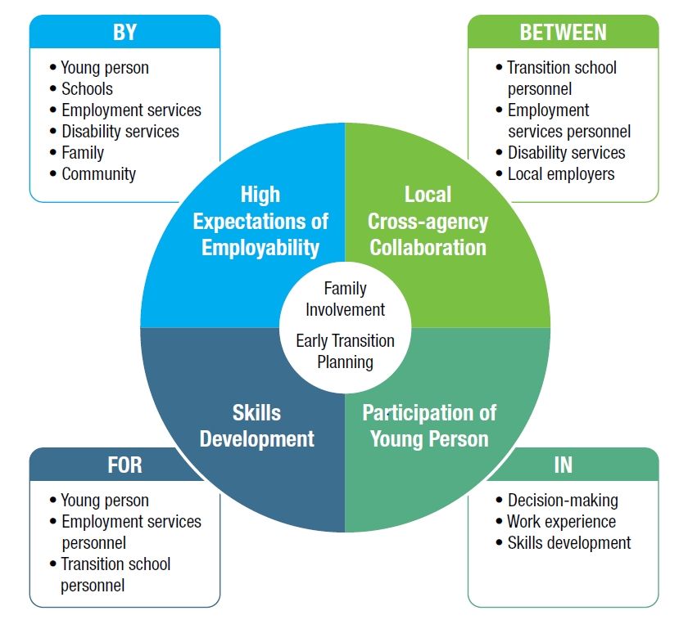

What this means:
Young people with disabilities are more likely to get and keep a job if they:
- have had a paid job in the community while at school
- have done work experience (multiple times) while at school
- have responsibilities for household jobs at home
- participate in work preparation activities at school
- have some social skills
- are as independent in self-care as they can be
- have received training and support in community travel
- believe they can work and will get a job when they leave school
- have people in their lives who believe they can work
- know people in the community and have good community networks

What does this tell us?
- Schools, families, communities and employment services play a crucial role in supporting young people with disability on their pathways to employment.
- The keys to the best outcomes are
  - Early transition planning,
  - Collaboration between service providers, educators, families and communities (the greatest barrier is the often poor collaboration between schools and post-school programs and services
  - Involvement of families,
  - Participation in work experience and work preparation programs,
  - Development of skills for transition to adulthood in the young person, their family, service provider personnel and educators,
and above all…
  - High expectations of the young person’s capacity for work and continued skill development during adulthood.

3 - Supporting young people to think about what they would like to do when they leave school
Many young people need support to think about and decide what is right for them. Service providers can help by working with young people to identify their strengths and what they like to do best. This will help uncover what skills they will need to make the transition from school work best for them.
It can help to think about these three questions:
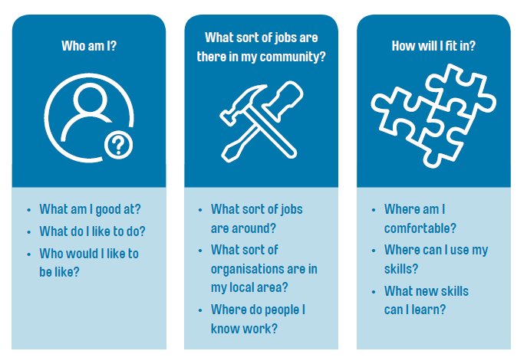

4. Whose job is it anyway? The role of supports in effective school to employment transitions
Research evidence shows that we get the best result when everyone is working together. All supporters need a shared vision for post-school achievement for students, and to understand each other’s roles.
Successful transitions from school to employment require early and effective collaboration and planning between students with disability, their families, schools, and community employment services. They require emphasis on self-determination and helping students to explore and develop their vocational skills, goals and career pathways. Best practice involves high expectations, cross-agency collaboration, work experience and opportunities to develop work skills.

The Role of Disability Service Providers
The door to employment should never be closed to people with disability. Community participation and other day service staff have a responsibility to work with people accessing their services to identify their goals as part of their individual plans. This includes any vocational, educational or employment goals.
Use these questions to think about how your disability service provider views employment:
- Do staff believe people with disability can work?
- What opportunities exist for people to know what work is?
- What does the organisation do to assist people to think about employment?
- Are NDIS plans being used to help find employment opportunities?
- How do organisations balance government expectations of people having a job with people’s right to choose not to work?

The role of employers
A central barrier to people with disability participating in the workforce is low expectations about their capacity to work. Low expectations can result from a lack of awareness of the many benefits people with disability can bring to the workplace.
Under The Australian Disability Discrimination Act (1992) it is against the law for an employer to treat a person unfairly because of their disability. A person with disability should be given equal opportunity to do a job, if they can do the main activities or ‘inherent requirements’ of the job.
Disability Employment Services can assist with addressing any concerns employers may have about recruiting people with disability. There is also financial assistance available to employers to help them provide suitable accommodations for employing people with disability. This might include:
- making reasonable adjustments to enable people with disability to access their workplace;
- providing employment-specific aids and equipment such as computers and modified desks;
- making reasonable adjustments to buildings, such as installing ramps; and,
- providing transportation for work activities, such as attending meetings.

5. Useful links and resources

Learning about disability
No matter which sector you work in, having an understanding of disability and human rights is important when providing support to young people to leave school and enter to workforce.
Disability Aware is a short, online course that will enhance skills and knowledge for working inclusively whether you are an employer, teacher, community worker or other service provider. https://www.nds.org.au/events-and-training/all-events-and-training/disability-aware-an-awareness-and-inclusion-program-2515
Disability and a good life: Thinking through disability is a longer, free online course addressing our understanding of disability, disability across the life course and other topics. https://www.futurelearn.com/courses/thinking-through-disability

Job Access
Job Access is the national hub for workplace and employment information for people with disability, employers and service providers. It provides information for people with disability, employers and service providers on available support, rights and responsibilities, video stories, downloadable information sheets, and links to information about medical conditions or disability types.
Workplace and employment information for people with disability, employers and service providers: www.jobaccess.gov.au/

Disability Employment Services
Resources relating to disability employment services for job seekers, employees, and employers: www.employment.gov.au/disability-employment-services

Ticket to Work
Local Ticket to Work Networks operate around Australia to support transitions to work utilising NDIS supports and coordinated interagency plans involving educators, community service agencies, LACs and employment services. They can help customise employment plans including a combination of work-focused curriculum, work experience and school-based apprenticeships and traineeships: www.tickettowork.org.au/
Ticket to Work resource outlining the NDIS and the interface with other services systems in the school to work transition: http://www.tickettowork.org.au/wp-content/uploads/2017/02/School-to-work-transition-and-the-NDIS-.pdf

School Leaver Employment Supports (SLES) as part of the NDIS
Fact Sheet for Students and Teachers: https://www.ndis.gov.au/people-disability/sles

NDIS
Access information about the National Disability insurance Scheme here: www.ndis.gov.au

Transition to Work
Transition to Work provides intensive, pre-employment support to improve work readiness for early school leavers aged 15-21 years, and help them into work (including apprenticeships and traineeships) or education.
Transition to Work operates as a separate service from DES and may be suitable for young people with less severe disability who do not meet the eligibility requirements for DES. https://docs.employment.gov.au/system/files/doc/other/em16-0023_transition_to_work_factsheet_02.pdf

Apprenticeships and traineeships
Employment and related economic outcomes achieved by young people with disability who graduate from an Australian apprenticeship or traineeship are similar to those for graduates without disability (Cocks, Thoresen & Lee, 2013).
Information on support for students with disability to do an apprenticeship https://www.jobaccess.gov.au/people-with-disability/support-do-apprenticeship

Open Employment
There are a range of programs to support employers to create job opportunities for people with disability including the Employment Assistance Fund (EAF) which gives financial help to people with disability and employers to buy work related modifications and services, PaTH Internships which are short placements in the workplace to give young people the opportunity to demonstrate their skills to a potential employer, and Wage Subsidies. Information on these programs can be accessed at https://www.jobaccess.gov.au/employers/available-support/196

Further Education or Training
Engagement in further education and training can help students with disability develop their work readiness skills and transition on open employment or higher education.
Further education and training options: https://www.jobaccess.gov.au/people-with-disability/finding-training-course-expand-your-skills

Self-Employment
Young people with disability can receive support through the NDIS and other programs to develop their own small business: https://jobsearch.gov.au/selfstart; https://vimeo.com/139302542

Video resources for People with Disability Preparing for Work
Online videos for people with low literacy skills to help understand the planning process, set goals, and choose providers http://www.healthyactivelife.org/
http://www.healthyactivelife.org/working.html
Living a Good Life videos: https://www.youtube.com/watch?v=tldRMSabtLY; https://www.youtube.com/watch?v=y4hiDSTCSxM; https://www.youtube.com/watch?v=-v3FiYGYMYw
Tools for school leavers, including a fun animation: https://www.nds.org.au/resources/transition-to-employment-tools-for-school-leavers

Decision-Making Online Resource
http://www.support-my-decision.org.au/decisions-big-and-small

