Ticket to Work News
May 2017
Welcome to our Ticket to Work newsletter.
We randomly put out a newsletter to share our resources, achievements and information to ensure that all young people with disability are able to take an employment pathway.
Ticket to Work grew out of research that showed participation in work experience and employment during secondary school are among the most significant indicators of post-school success for young people with significant disability.
We take a partnership approach to improving the employment outcomes of young people with disability.

We are very proud of the work of the members of the Ticket to Work networks across Australia. They consistently go above and beyond to ensure that young people with disability have the opportunity to achieve their employment goals.

For more information see our Ticket to Work website

Upcoming Training
This two-day specialised training program in using Customised Employment approach and the Discovering Process. Gaelen William from National Disability Services has been training NDIS providers, Families and Disability Employment Services (DES) in these techniques as part of the National Disability Insurance Agency’s school-to-work project in Western Australia (see below story WA Employment Pilot). The project, part of Ticket to Work gives secondary students from Years 10 and above support focused on achieving open employment or self-employment in the community.
Date: Tuesday 13/06/17 and Wednesday 14/06/17
Cost: $200.00 including GST per person, 3 for 2 available. Program fee includes all training material and day catering.
Registration: https://www.eventbrite.com.au/e/customised-employment-training-parkville-tickets-34530138574
Please note: This course has been heavily subsidised with thanks to the Victorian State Government’s NDIS Transition Support Package funding.
Our Results

Since Ticket to Work went National at the beginning of 2014, Ticket to Work networks have created thousands of opportunities for young people with significant disability. We have shown that when given the right opportunity and support young people with significant disability can achieve:
1,977 | Young people with disability commenced in work experience and work preparation activities
807 | Jobs have been created for young people with significant disability
1,383 | Employers across a diverse range of sectors have supported young people in their workplaces
306 | Schools are offering Ticket to Work activities to their students with disability
465 | Organisations and agencies are now part of 31 Local Ticket to Work Network across Australia

If you like to have a look further at breakdown of our data. Click here

A recent independent longitudinal evaluation found that Ticket to Work is creating positive longer term social and economic outcomes for young people with disability.

Compared to other young people with similar disability Ticket to Work participants were:

ALMOST  50%  MORE LIKELY TO  COMPLETE  YEAR 12 | 4x  MORE LIKELY  TO BE  IN WORK | EXPERIENCING  HIGHER  LEVELS  OF SOCIAL  PARTICIPATION,  QUALITY  OF LIFE  AND WELLBEING | 100%  OF TICKET  TO WORK  PARTICIPANTS  HAD GAINED  FURTHER  EDUCATION  QUALIFICATIONS
Our research and papers
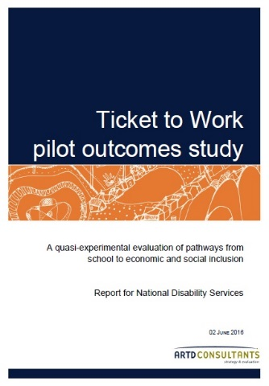 | Ticket to Work pilot outcomes study  The outcomes study by independent consultants, ARTD, compares past Ticket to Work participants with other young people with disability and shows impressive outcomes across a broad range of indicators including levels of job satisfaction, independence and social participation.  Full document here
Does training enhance the employment prospects of people with disability?  We were keen to explore the effect of training for people with disability and had a look at literature available. We found that completing a Vocational Education and Training (VET) qualification not only strongly improves the chances of getting a job, but also keeping it. Though not all training is equal in providing employment pathways. Find out more:  Full document here |  | 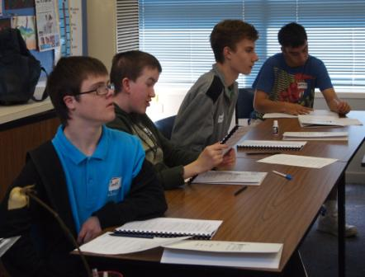

New resources
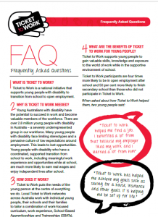 | Ticket to Work Frequently Asked Questions  The Ticket to Work FAQ contains our most commonly asked questions. If is great resource to get some information about what we do and how we do it.  Full document here
We have two new visual resources looking at transition:  How to create successful post school employment outcomes for students with disability looks at the conditions to create optimum employment opportunities for young people with disability. It developed from the evidence base and our experience at Ticket to Work.  Document here  Pathways to employment for secondary students with significant disability assist when looking at the pathways to employment of young people with significant disability through school, NDIS and/or DES with the end outcome of Meaningful Open Employment or Self Employment. It aims to explore activities before leaving school that enhance employment outcome post school.  Document here |  |  | 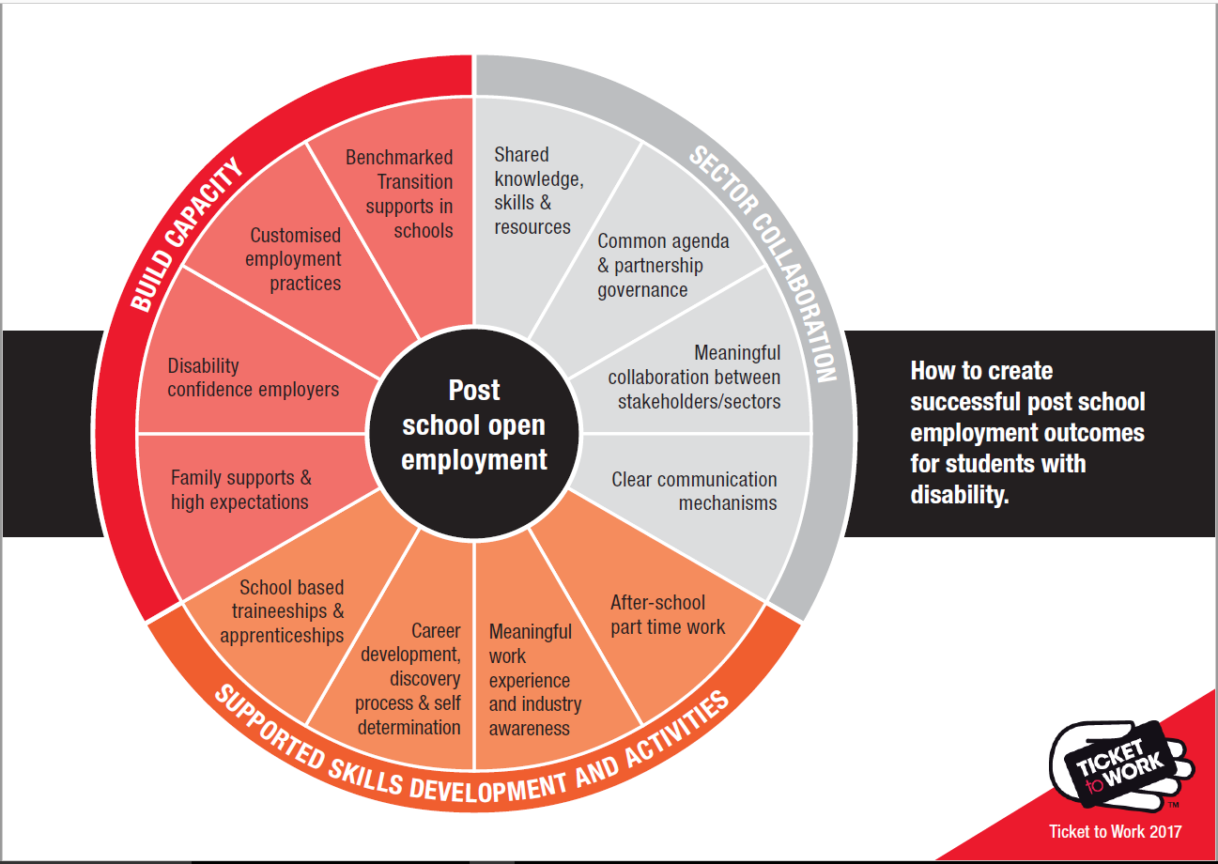
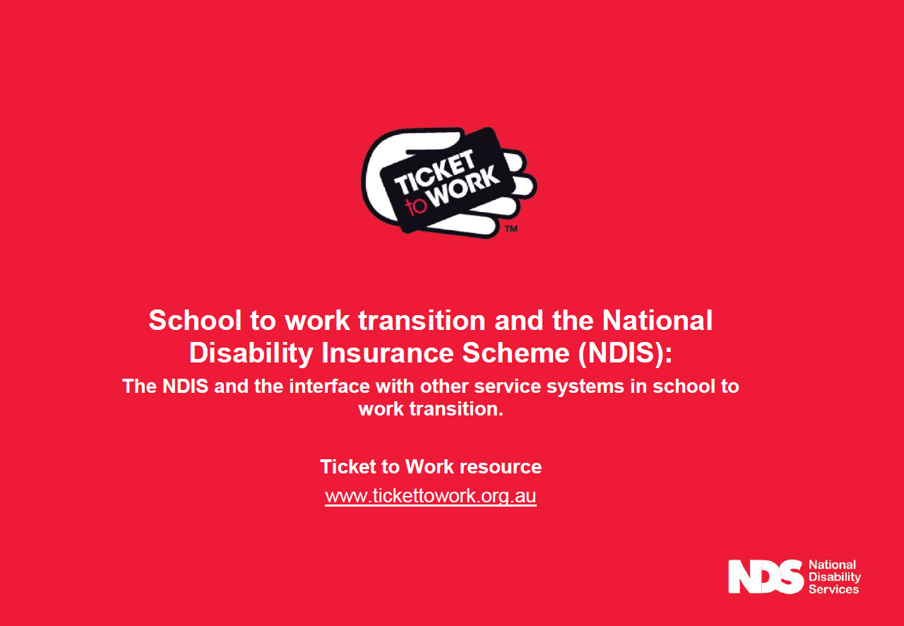 |  | School to work transition and the National Disability Insurance Scheme (NDIS).  In the area of school to work transition, the NDIS interfaces with the school education, training and the employment sectors. Ticket to Work networks have found that there can be some confusion around responsibilities for activities that would benefit school to work transition. We have put the following information together to support decision making.  Full document here
Guide to setting up an Australian School Based Traineeships/apprenticeship for Disability Employment Service Providers (DES).
This document was developed to assist DES providers and other when setting up a school based traineeship/apprenticeship for a student with a disability. It includes frequently asked questions that we often get.
Full document here
Our stories
Here are stories that have been in the media recently. They highlight the fabulous achievements of young people involved in Ticket to Work and our Network members.

Program helps youth into work
Stephens Parsons work life is testimony to what can happen when a person with a disability gets an opportunity to improve his skills. Mr Parsons is part of Ticket to Work which helps young people get into the workforce. Today, he works at the Burleigh Surf Life-saving Club while he completes a Certificate III in Hospitality. “I really enjoyed working at the surf lifesaving club. I love talking to people and being around them” he said. Mr Parsons was full of praise for Ticket to Work.
Full story here

Tasmanian Ticket to Work participants get recognised for their great work.

Ticket to Work participants have taken a clean sweep at the Tasmania training awards.
Jacob, Hannah and Rhiannon are all part of the Southern Tasmania Ticket to Work initiative. Well done on your awards
Full story here
Ella’s Story
Ella took part of a project between Ticket to Work networks in Western Australian and the National Disability Insurance Agency.
“This project comes at the critical juncture between childhood and adulthood when young people are making decisions about their future. Support is available to students with very significant disability who never before thought work was an option,” Ms Kerry Stopher from the NDIA.
Full story here

WA Employment Pilot: A case study with Inclusion WA

This month, NDS sat down with Jessica De Masi, Coordinator at Inclusion WA, to talk about the organisation’s involvement in a pilot that aims to give students the best opportunity to start their post-school lives with employment.
This pilot is founded on the belief that all people who wish to work can, if they are given the appropriate support.
Full story here watch the video

Innovative Careers Program wins award

Young people with disability are challenging limiting stereotypes and preparing for independent lives after school.
A group of senior students at Naranga, a specialist school in Frankston, are proving that young people with disability are able to develop the skills needed for success in the world of work.
Full story here

A message from the National Ticket to Work team
We would like to thank everyone that has supported and been involved in Ticket to Work. A list of some of our supporters is here and testimonial are here.
Please get in touch if you would like to support, be involved or would like more information:
Michelle Wakeford,
National Ticket to Work Manager
National Disability Services (NDS)
M: 0413 750 745
E: michelle@tickettowork.org.au

