Proceed with caution:

Vocational and Applied Learning Pathways in Senior Secondary Schooling: the Firth Report and the Victorian Government’s Response

Introduction

In November 2019, the Victorian Government commissioned the review into vocational and applied learning pathways for senior secondary students, led by former Victorian Curriculum and Assessment Authority Chief Executive Officer, John Firth.
The major review was commissioned to make recommendations for reform with two key aims:
- to ensure all Victorian secondary school students have access to high-quality vocational and applied learning options
- to look for ways to improve transitions for students between school, post-secondary education and work.
Firth delivered his final report in November 2020. The Victorian Government delivered its response that same month, accepting in principle all of the review’s recommendations, stating:
They provide a set of transformative reforms that will improve the skills and work readiness of young people by:
- lifting the quality and perception of vocational education
- helping more students access high-quality programs, and
- providing students with a vocational pathway that gives them the skills they need to move successfully into further training and jobs. Report here.

Ticket to Work supports the Government’s view that: the senior years of school are a critical period in a student’s life and that “they are especially critical now to be sure young people can get on to a good pathway – one that gives them the skills they need, and that leads them into further training, education and, ultimately, a great job”.
We welcome the Government’s recognition that broad engagement with stakeholders at every stage of implementation will be key to the success in implementing this reform agenda.

This paper accepts that invitation.

It warns that that good intentions will not be enough to deliver the two stated aims for the reforms if, as explicitly stated, the reforms are intended to benefit all students including those with disability (all should mean all). More than this, we are deeply concerned that the reforms may well lead to exacerbating existing disadvantage and undermine existing initiatives that are shown to deliver improved education and employment outcomes for these young people.

Our Concerns

Flaws in the Proposed Integrated Senior Secondary Certificate

The Review recommends that Victoria is best served by an integrated senior secondary certificate system:

An integrated certificate will empower students to personalise a senior secondary pathway that is aligned with their interests, strengths and aspirations, and to create an optimal subject grouping that exposes them to learning that is most relevant to their desired post-school pathway.

An integrated certificate will provide all senior secondary students with a genuine and identifiable vocational pathway that aligns with their personal strengths, interests and post-school aspirations and exposes them to the most relevant learning for their next move.

However, the Review goes on to state that the new integrated certificate would not cater for students who would usually study Foundation VCAL [Victorian Certificate of Applied Learning], the majority of whom are students with disability. Instead, these students would be funnelled into a new certificate called the Foundation Pathways Certificate.

Our concern is that this is not in line with evidenced based practice as to what constitutes quality senior schooling. The net effect will be to reduce the life chances of students with disability.

Many of the drivers of low labour force participation rates of people with disability start at school. People with disability are significantly less likely than their peers to complete Year 12 and less likely to participate in work experience. They are more likely to face exclusion from the labour market, obtain fewer educational qualifications, are more likely to experience poverty and be socially isolated (Athanasou et al. 2019, SVA 2020).
Problems with a smooth transition from school to the labour market for young people with disabilities are widely recognised: unemployment rates are high (e.g. Siperstein et al., 2013; Eurostat, 2014) and a significant majority are excluded from the labour market (e.g. Arvidsson et al., 2016; Tideman et al., 2017). From an Australian perspective, transition to employment support systems are failing young people with disability, resulting in reduced opportunity for social and economic participation and the marginalisation of this group (Beyer, S & Beyer, A (2017), Thiele, R, Bigby, C, Tideman, M (2018).
Unless students with disability receive a high quality senior school education experience, they are unlikely to successfully transition from school to work, with their consequent exclusion from social and economic participation. The Firth Review reforms reduce access to quality inclusive education for students with disability. In doing so, the proposals ignore the substantial body of international and local evidence on what works for students with disability in their senior secondary years.

Schools have the central role in preparing their students for adult life as contributing citizens (Lindqvist, 2012). The importance of preparation during school for a successful transition from education to the labour market for young people with intellectual disability cannot be overstated (Thiele, R., Biby, C., Tideman, M (2018).

The Victorian Equal Opportunity and Human Rights Commission found that poor education is one of the key reasons why the economic and social participation rate of people with disabilities is so low (Victorian equal opportunity and human rights commission (2012).

Victoria does poorly in supporting school to work transition for students with disability (NDIS participants), compared to other states and territories. The proposed recommendations will further cement the disadvantage of Victorian students with disability.

The Shergold Review (2020) identified systemic and structural factors can inhibit the participation of young people with disability in senior secondary schooling. The review stated that ‘interventions to support senior secondary students with disability are essential not only at school, but beyond the classroom’ (Panel for education council review of senior secondary pathways into work, further education and training 2020).

It is important that any changes to senior school in Victoria are evidenced based, in line with our international agreements and do not further restrict the life chances of young people with disability. Denying students with disability their right to genuine educational opportunity.

Children and Young People with Disability Australia (CYDA) states: ‘Despite the high value and strong evidence base linking educational attainment and improved life outcomes, students with disability are frequently denied educational opportunities. Even though there have been significant advances in recognising and affording people with disability rights and equal opportunities, ableist attitudes are still entrenched in the Australian community and very much shape the typical school education experiences of students with disability’ (Children with disability Australia (2015).

The United Nations Convention on the Rights of Persons with Disability 2006 (CRPD) and the Convention on the Rights of the Child 1989 (CRC) clearly established the right of children with disability to receive a quality and inclusive education. The evidence base describing egregious breaches of the human rights of children and young people with disability in schools is rapidly increasing [See, for example, CYDA: August 2016].

The UN Committee on the Rights of Persons with Disabilities (2016) stated students with disability should receive the support to ensure their effective transition from learning at school to vocational and tertiary education, and work. Article 24 of the United Nations Convention on the Rights of Persons with Disabilities (2007) promotes, amongst other things, education for all to their full potential.

Likewise, the National Disability Strategy [NDS: key policy strategy 3.1] identifies the need for greater employment opportunities as a key to improving economic security and personal wellbeing for people with disability: ‘Economic security is critical to the wellbeing and empowerment of people with disability and underpins the ability to make progress in all other outcomes and areas of life.’ [Department of Social Services, 2018, p. 42]

The Strategy [key policy strategy 5.5] also identifies the need for high quality programs designed to create smooth transition from education and employment [Department of Social Services, 2016].

The Disability Discrimination Act 1992 (Cth) makes it unlawful to discriminate on the grounds of disability across a range of criteria that include denying access to any benefit provided by the educational authority, and developing curricula that will exclude a person from participation. Similarly, the Disability Standards for Education 2005 (Cth) require schools to make their programs accessible to students with disabilities and make reasonable adjustments to enable student participation (Disability Discrimination Act 1992), (Disability Standards for Education 2005), (Brett, M., Harvey, A., Funston, A., Spicer, R. & Wood, A. (2016).

The Royal Commission into Violence, Abuse, Neglect and Exploitation of people with disability has highlighted issues with school to work transition finding that currently there is a polished pathway to poverty from school to day support and supported employment (as opposed to open employment). The commission Identified organisational barriers from education and training made it difficult in access skills training education and lack of support to engage with and complete qualifications.
The Commission is planning to explore this area further as part of their enquiry (Public hearing 9 Sydney).

Young people with disability
Students with disability are a large and growing cohort in Australian schools: almost 1 in 5 (20%) students receive educational adjustments because of disability. (2019 Nationally Consistent Collection of Data on School Students with Disability (NCCD).
The single largest group of students who required adjustments have cognitive disability (55% of students with disability who receive adjustments).

The Collection of Data for School Students with Disability shows that in Victoria:
- 17% of Victorian students received education adjustments due to disability.
- Of these students, 36% received the highest level of adjustments - quality differentiated teaching practice (QDTP).
- The largest disability cohort in Victorian schools is cognitive disability at 8.8% of the student population. (2015 collection of data for school students with disability NDCO)

On Track data show
- Victorian Indigenous students are over-represented in the Program for Students with Disability (PSD) population, with 3.6% of PSD-eligible students being Indigenous, compared to 1.6% of the Victorian school population being Indigenous.
- 73% of students in special schools reported they had not received any assistance with job-seeking or job-placement. (Victorian Government (2015) On Track Survey 2015)
- Only 6% of ex-students in Victorian special schools were in open employment six months after completing school. (Victorian Government (2015) On Track Survey 2015)

It is important to note that the majority of students with disability attend mainstream education settings: 89% of students with a disability attend mainstream schools; 80% of students with severe or profound disability attend mainstream schools.
Though Year 12 or equivalent attainment for young people with disability is on the rise, it is still much less than their peers without disability. For students with disability, only around 32 per cent complete Year 12 (Australian Institute of Health and Welfare (2019a).
Australia has one of the lowest rates of employment for people with disability in the OECD and Victoria has one of lowest rates in Australia [see graph below of NDIS participants]. A University of Sydney study found that the education and employment gap between young people with disability and those without disability has widened (Emerson & Llewellyn, 2014).

NDIS Data

NDIS Baseline Outcome Indicator Data as at 30 September 2020 (Downloaded from NDIA website here.

In responding to the Firth Review, the Government has the responsibility to ensure any reform is evidenced based and built on learning international and in Australia.
What the research is telling us
International Research
There has been significant international effort to determine the elements to improve economic participation of young people with disability.
The research has produced a consistent set of predictors of in-school activities that positively correlate with post school success in education, employment, and independent living (Carter, Erik & Austin, Diane & Trainor, Audrey. (2012), (Mazzotti, Valerie L.; Rowe, Dawn A.; Kwiatek, Stephen; Voggt, Ashley; Chang, Wen-Hsuan; Fowler, Catherine H.; et al. (2020), (Sheppard, L., Harrington, R. & Howard, K. (2017).
From 1987 to the present, the U.S. Department of Education has funded a series of National Longitudinal Transition Studies which followed youth with disabilities during and after high school.
The research has produced a consistent set of predictors of in-school activities that positively correlate with post-school success in education, employment, and independent living. Those that are statistically significant include:
- participation in career and vocational education. (Vocational education and training (VDSS)
- inclusion in general education (learning with peers without disability)
- completing high school certificate
- expectation of employment
- self-determination, and
- paid-employment/work experience (Mazzotti_2020_CDTEI.pdf), (Mazzotti, Valerie & Rowe, D. & Sinclair, James & Poppen, Marcus & Woods, William & Shearer, Mackenzie. (2015)
Research has found that students with disabilities who had career-related instruction and vocational training at school: were more likely to graduate from high school and more likely to gain employment in full-time competitive jobs after high school (Benz MR, Lindstrom L, Yovanoff P. (2000), (Daviso, A. W., Baer, R. M., Flexer, R. W., Meindl, R. (2016) (Wonacott (2000) as well as Shandra and Hogan (2008).
Students with disabilities who attended vocational education programs had higher employment rates and salaries 5 years after high school graduation (Harvey, 2002). (Lindstrom, Kahn, & Lindsey, 2013).

For decades, research has shown the strong relationship between the experience of work during secondary school and higher post-school employment for youth with disabilities (Colley & Jamison, 1998), (Benz, Yovanoff & Doren, 1997).

Consistently, the most prominent factors shown to be associated with successful post-school employment outcomes are paid and unpaid work experiences during the last years of secondary school and the completion of a high school diploma” (Luecking 2009).
An ILO report on inclusive apprenticeships and workplace learning found countries with apprenticeship based technical vocational education and training systems have lower youth unemployment rates (International Labour Organisation, 2018, p. 2).

It is important to note that the Firth Review’s proposed Foundation Pathways Certificate offers a general vocation program contrary to international research findings, that students with learning disabilities enrolled in occupationally specific programs experience better post-high school employment outcomes (Wagner, M. and Newman, L. (2015).

Australian data
Thoresen, Cocks and Parson (2019), in their three-year national longitudinal study, found that VET and VET delivered to Secondary Schools (VDSS) are strong vocational pathways with good employment outcomes for young people with disability, particularly VET or VDSS which includes some form of work-based training such as apprenticeships and traineeships. This suggests that VDSS and School based Apprenticeships and Traineeships (SbAT) can provide successful vocational pathways in the transition from school for young people with disabilities including those with an intellectual disability. The identified economic outcomes include high workforce participation and employment rates and income, comparable to similarly aged Australians without disability (Cocks, Errol and Thoresen, Stian H. 2013).
Cocks and Thoresen (2013) found that VDSS is advantageous for young people with disabilities as support can be provided by the school, as well as other involved stakeholders which may include the employer, DES, Group Training Organisations (GTOs), Registered Training Organisations (RTOs) including technical and further education (TAFE) institutes, as well as family, friends and work colleagues. They found that “VDSS can be a successful vocational pathway in the transition from school for young people with disabilities” (Cocks, Errol and Thoresen, Stian H. 2013, p.8). This is confirmed in the Shergold review (Panel for the Education Council Review of Senior Secondary Pathways into Work, Further Education and Training 2020).

Polidano (2010) also confirms that completing a VET qualification not only helps people with a disability to find work, but it also increases their chances of sustaining employment into the future.
Apprenticeships and traineeships have been shown to be beneficial pathways for people with disabilities, particularly for people with intellectual and learning disabilities (Lewis, Thoresen & Cocks 2011a, 2011b), for obtaining qualifications and employment as they combine training and education with practical work. Although the outcomes among apprenticeship and traineeship graduates with disabilities are similar to graduates without disabilities (Ball & John 2005), people with disabilities are less likely to undertake and complete apprenticeships and traineeships than their peers without disabilities (ANTA 2000; Bagshaw & Fowler; Cavallaro et al 2005; Griffin & Beddie 2011; NCVER 2011c; National VET Equity Advisory Council 2011).
It has been found that students with a disability enrolled in an apprenticeship or traineeship have better employment outcomes, when compared against other types of VET courses (Barnett 2004; Clark 2007). Likewise, training that involves practical experience in the workplace is more likely to lead to employment for young people with a disability (Dawe 2004; Clark 2007).
Cocks and Thoresen (2013), found economic outcomes in participating in apprenticeship and traineeship for people with a disability included high workforce participation and employment rates and income, comparable to similarly aged Australians without disability” (2013, p.8). This is unlike other forms of employment where there is an ‘unexplained’ income gap between people with disability and those without disability (Mavromaras, 2009).
Students with disability are not getting effective career development and the opportunities which would enable them to have a degree of control (self-determine) over their own futures. NDIS data found when young people with disability were asked ‘What involvement do/did you have in planning for your life after your school years?’ Approximately 33% said that they had no input into decisions about their life after school, 47% had some input and only 20% said they made the decisions. As a key predicator of post school success is self-determining your own future, there is a clear need to improve in our education systems in this regard (NDIS Participant Outcomes Report. 2019).
Many young people with disability face challenges engaging in education. This is reflected in the overall lower levels of educational attainment for people with disability.
The Shergold review (2020) found “Young people who do not complete Year 12, or gain equivalent qualifications, experience greater difficulty in making the transition from school to post-school education and training and employment (Lamb, S., Jackson, J., Walstab, A. and Huo, S. (2015). These young people are much less likely to gain full access to economic, political and social opportunities, and this can affect their ability to achieve financial stability and independence” (Australian Institute of Health and Welfare (2017), (Panel for the Education Council Review of Senior Secondary Pathways into Work 2020).
Lessons from the Ticket to Work experience
The Ticket to Work initiative was established in response to poor and falling school to work transitions for young Australians with disability.
We took the international predictors of in-school activities that positively correlate with post-school success, incorporating them into the model called Ticket to Work; the intention being to test if we could replicate the same positive effects in Australia.
The theory of change we were testing is:
Connecting a student with disability to the world of work before they leave school through a coordinated approach greatly improves the likelihood of securing ongoing open employment and creates better economic and social outcomes.
The Ticket to Work model takes a place based collaborative approach that leverages the power of cross-sectoral partnerships to provide individualised support to secondary students with disability. These networks facilitate the blending of existing resources to provide coordination and scaffolding of the relevant supports for young people with disability. In Victoria, participants are on the Department of Education’s Program for Students with Disability (PSD) and the majority have a cognitive disability.
The collaborative partners include schools, families, employment services, training organisations, post school providers, NDIS supports and employers.
Students take part in a range of activities that are tailored to their needs. Those activities include:
- VET delivered to Secondary Schools (VDSS)
- Australian School based Apprenticeships and Traineeships (ASbAT)
- Work experience/placement
- Career development
- After-school work
- Self-employment during secondary school (microbusiness)
Ticket to Work has successfully trialled and tested what works to support students in secondary school to ensure that they are equipped to pursue a self-directed pathway to address their interests, aspirations, and goals and, explicitly, have a pathway to open employment.

The Ticket to Work Model: Outcomes
Ticket to Work’s connected approach (34 local networks; 205 schools; 145 local organisations; 2,436 employers) has delivered 1,649 jobs for students with disability. Recent evaluations of elements of the Ticket to Work model indicate:
- The Ticket to Work model has a number of social and fiscal benefits. [SVA 2020]
- Ticket to Work participants post-school are substantially more likely than a similar comparison group to:
  - work in open employment
  - complete year 12
  - participate in the labour force
  - be involved in community and social activities (ARTD 2019)
- Ticket to Work’s approach is working for key stakeholders according to an evaluation involving employers, parents and network members and is in line with international good practice and research (Wakeford, 2019, Kellock 2020, ARTD 2018).
- There is a need to focus on how the different sectors working can work in concert to improve employment outcomes and raise expectations for young people with disability (Meadows, 2020)
- Ticket to Work assists with the effective integration of mainstream and disability support, and it has been shown this approach reduces duplication (ARTD, 2019).
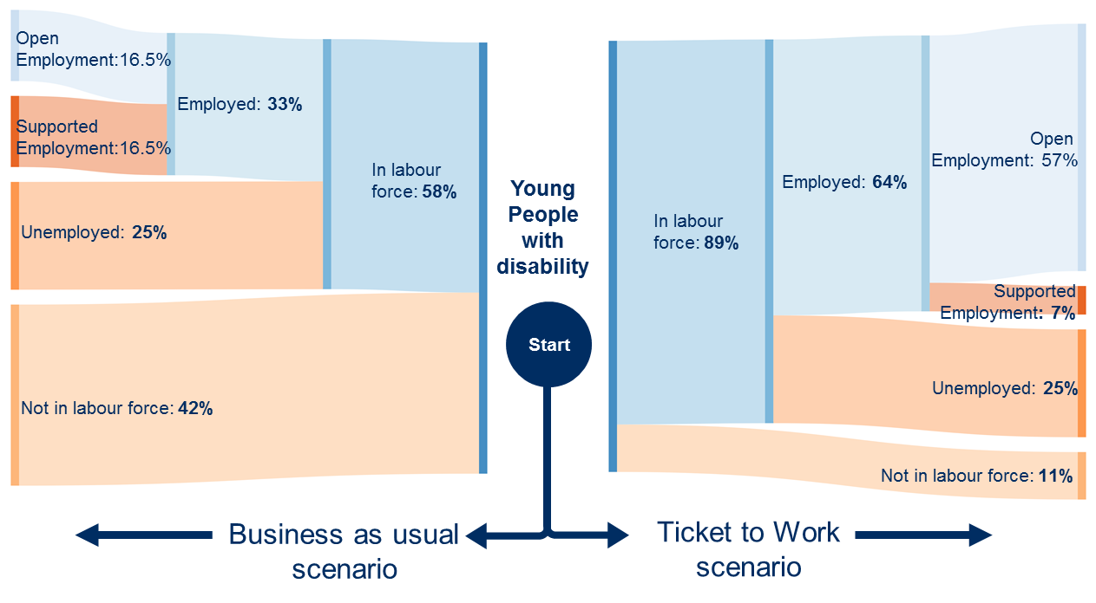
The above Figure 1 indicates the findings of a comparison study. Ticket to Work participants showed improved outcomes compared to young people that did not have Ticket to Work support (Business as usual)
Ticket to Work participants are:
- Nearly 50 % more likely to complete year 12
- More likely to be studying post school (31% to 23 %)
- Much more likely to have obtained further qualifications (32% to 15%)
- Over three times more likely to be in open employment post school
- Experience higher levels of social activities

The below figure 2 shows more people are in employment, education or training under the Ticket to Work scenario compared to the Business as Usual scenario.

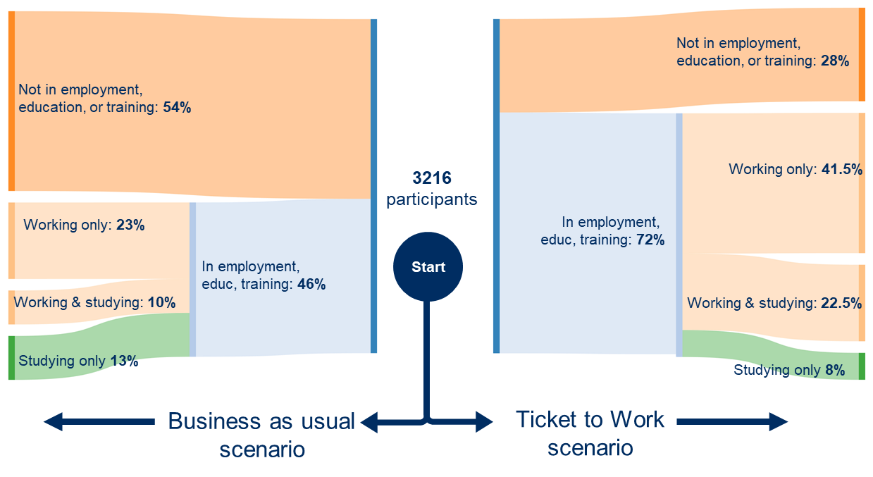
The above figure 2 Ticket to Work Scenario comparison for employment outcomes
The 2019 evaluation of Ticket to Work showed 67% of participants were enrolled in vocational education or training (VET) as part of their senior school certificate. The majority (82%) completed their VET qualification as part of an Australian School based Apprenticeship or Traineeship (ASbAT) (Hawkins & Rasheed, 2016, p. 26). Of those who participated in an ASbAT, 78% were employed, 15% were unemployed and 7% were not in the labour force in 2018. These findings are significantly higher than who did not participate in an ASbAT.
The evaluation also found that more career and vocational experiences created better post school outcomes; students were much more likely to be employed post school if participated in 3+ workplace learning and/or work experience (77% to 33%).
The Ticket to Work findings support the international experience and the contention that participation in school-based apprenticeships/ traineeships and VDSS enhance the likelihood of successful transition outcomes.
While not underestimating the challenges, Ticket to Work has demonstrated in significant numbers that young people can thrive in open employment when prepared and supported while at school through a coordinated approach.
Implications for the proposed Firth Reforms
While workplace learning opportunities are beneficial to all youth, it has been found they are particularly valuable for young people with disabilities.
The poor outcomes for Victorian students with disability suggest that there remains a critical need to expand quality work-based learning opportunities for young people with disability and to integrate these experiences into secondary education.
In Australia it has been identified that it is ‘crucial that young people with disability receive the support required to participate in the workforce as early as possible to drive effective long-term employment and maximise the benefits of improved standards of living and social inclusion that come with employment’ (Deloitte Access Economics (2011).
Research has consistently demonstrated that education and employment outcomes for young people with disabilities can be significantly improved by frequent and systematic exposure to a variety of real work experiences while at school. The persistently low employment rates of youth and young adults with disabilities suggest that these types of experiences should be integral to secondary education for students with disabilities, regardless of the nature of the disability or the need for special education services (Luecking R, Gramlich, M (2003).
Importantly to note, given the Firth recommendations, ‘segregation of students with disability has found to increase the pervasiveness of bullying against students with disability’ (Wagner, M., Newman, L., Cameto, R., Garza, N., & Levine, P. (2005). The largest, longitudinal study of education outcomes of 11,000 students with disabilities, the National Longitudinal Transition Study, showed that more time spent in a general education classroom was positively correlated with higher scores on standardized tests of reading and math, fewer absences from school, and fewer referrals for disruptive behaviour. These results were independent of students’ disability, severity of disability, gender, or socio-economic status (Blackorby, Chorost, Garza, & Guzman).
There are clear links between the young person with a disability’s self-image and the degree to which schools foster inclusiveness and prolonged exposure to “horizon-limiting views and experiences” may see these beliefs become internalised and the person’s capacity to recognise their potential diminished (PWC 2011).
Previous research has shown that quickly moving young people with cognitive disability into real jobs that are well-matched to their interests and have growth potential positively impacts job retention (Cook et al. 2005; Luecking and Fabian 2000, SVA 2020).
This approach is particularly useful for many students with learning difficulties or disability, as generic skills development is not easily transferred from the classroom and into the workplace. Work placement accompanied with supported training in a real world context is preferable. There is extensive evidence that ‘place and train’ is much more successful than a flow-through models such as ‘train and place’ for this cohort of students.
This is why School based traineeships and VET with Structured work-place learning can be successful for many students with disability, if designed well with effective supports. With this in mind, resources can be better utilised to ensure Victorian students with disability get access to quality VET and SbATS and ensure authentic on-the-job experience, with the effective support.
Correspondingly, evaluations of Ticket to Work show participants who engage in School-based Apprenticeships and Traineeships (SbATs) are much more likely to be in employment post-school than students who did not, and also more likely to complete their secondary education (Hawkins & Rasheed, 2016).
Conclusion
We are encouraged by the aims of the reform, that being:
- to ensure all Victorian secondary school students have access to high-quality vocational and applied learning options
- to look for ways to improve transitions for students between school, post-secondary education and work.
Yet all must mean all, and there need for significant reform to improve transition for students with disability.
Senior school vocational and work-based learning experiences have been shown to be one of the strongest predictors of adult employment success for students and with disabilities. There is a substantial body of literature about what make a quality work-based learning program that the Victoria government can draw upon.
Using these predictors will allow state government, schools and services to be strategic and to ensure a good return on their investments: providing vocational, senior school and transition services to students with disability have the best chance of improving students’ post-school outcomes (What to Know About Work-Based Learning Experiences), (Federal Youth Transition Plan (2020).

Recommendations
The Government’s response should be explicitly predicated on ensure any education reforms are evidenced based and address the needs of all students including those with disability.
Drawing on the extant international and national evidence strongly, we would recommend a commitment from the Victorian Government that:
- All young Australians be given equitable access and opportunity to become confident and creative individuals, successful lifelong learners, and active and informed members of the community.
- Explore the learnings from Ticket to Work initiative and other successful approaches.
- Offers an inclusive certification system rather than a dual certificate system where students with disability are not given the full benefits of a senior school experience that other students can experience including VCE, VDSS and SbAT.
- Ensures students with disability are afforded genuine opportunities to participate in quality SbAT; including through making Head Start accessible to students with cognitive disability, by ensuring supported and including Certificate II traineeships.
- Ensures access to a VET qualification or School-based Apprenticeship or Traineeship with the allocation of time spent by students at school, with a registered training organisation, or in the workplace being based upon what is in their best interests, rather than upon funding arrangements or administrative convenience.
- All students have access to career education and work exploration activities, regardless of their chosen pathway or locality. They need to be provided with individualised, objective, unbiased and up-to-date career information - data is showing students with disability are not afforded the same opportunities as their peers.

- Ensures students with disability have multiple opportunities to engage in workplace learning and career development while at school.

- All senior secondary students with disability should have access to work exploration in school and, in collaboration with disability support groups, have an individual post-school transition plan put in place prior to leaving school.
- Recognises in policy and practice that education is a key to offering economic opportunity and social mobility to all young Australians, no matter what their background or circumstances. Students should have equitable access to high-quality schooling that offers them the best prospect for leading successful lives.
- Establish a Technical Assistance Hub, preferably in collaboration with the Federal Government, as proposed in the Shergold review. The Technical Assistance Hub provides a vehicle for ongoing collaboration and sharing of good practice, it blends research and evidence with the development of practical resources to assist state education agencies and service providers to ensure disadvantaged students, including those with disabilities, make successful post-school transitions.
The Firth Review states that it is essential that all students have access to quality senior school program that gives them the best life chances. We must ensure all means all. Students with disability deserve no less.

Appendix
Ticket to Work evaluations
Ticket to Work in its aim to improve pathways and opportunities has completed a number of investigations and evaluations into the elements of model. These can be accessed at tickettowork.org.au/research/. These include:
Title: Ticket to Work Valuation of key outcomes (2020) by Social Venture Australia (SVA)
Focus: SVA took a conservative approach to evaluating the post school outcomes of Ticket to Work over a 3 year period. They found that the Ticket to Work model has the ability to significantly reduce government expenditure while increasing the number of young people with disability to gain meaningful employment and experience improved social outcomes.

The report
Infographic summary of report
Title Beneficial for all: The After School Job (2021) by Dr William Crisp
Focus: This report explores a three year project that aimed to create opportunities for secondary school students with a disability to participate in after school jobs. The evaluation provides an overview of the broad policy context, details the Ticket to Work model, the rationale for the project, and lists the project outcomes.

The report

Title: Employer Experience of employing young people with Intellectual/Cognitive disability (2020) by Peter Kellock
Focus: This paper reports on the experience of employers who offer work opportunities to young people with intellectual disabilities. The paper considers aspects of the employer experience and how best to meet the needs of employers in order to increase the number of job opportunities available for young people with intellectual disabilities.
The report
Title: Parent engagement in school to work transition for their child with disability (2020) by Michelle Wakeford
Focus: Having supportive family and social relationships is one of the main factors associated with a successful transition from school or vocational programmes to employment. This paper explore the literature regarding parents’ experience of their child with a disability’s transition from school and looks at the experience of parents involved in Ticket to Work.
The report
Title: Collaboration – the key to unlocking a successful future for young people with disability (2019) by Dr. Denis Meadow
Focus: This paper examines the literature and explores interagency collaboration as a mechanism to improve post-school transitions for students with a disability.
The report
Title: Ticket to Work Network Analysis (2019) by ARTD Consultants
Focus: This report provides the findings from a partnership assessment for nine Ticket to Work networks operating in five Australian states. It identifies key successes and challenges of Ticket to Work partnerships and how they work to support young people with disability into employment.
The report
Title: Effective school to employment transitions for young people with disability. A Rapid Review of the Literature (2017). Sheppard, L., Harrington, R. & Howard, K.
Focus: This Research to Action Guide articulates the key components of best practice for supporting the transition from school to employment for young adults with disability in Australia, based on the best available evidence.
The report
Other reports/research/submission can be found at Ticket to Work Research.

References

Benz MR, Lindstrom L, Yovanoff P. (2000) Improving Graduation and Employment Outcomes of Students with Disabilities: Predictive Factors and Student Perspectives. Exceptional Children.

Beyer, S & Beyer, A (2017). A systematic review of the literature on the benefits for employers of employing people with learning disabilities. Mencap.

Blackorby, Chorost, Garza, & Guzman, 2003 National Center on Inclusive Education, 2011.

Brett, M., Harvey, A., Funston, A., Spicer, R. & Wood, A. (2016). The Role of Inherent Requirement Statements in Australian Universities. Report submitted to the National Centre for Student Equity in Higher Education (NCSEHE), Curtin University: Perth.

Carter, Erik & Austin, Diane & Trainor, Audrey. (2012). Predictors of Postschool Employment Outcomes for Young Adults with Severe Disabilities. Journal of Disability Policy Studies. 23. 50-63

Cocks, Errol and Thoresen, Stian H. 2013. Social and economic outcomes from VET in schools for people with disabilities: Initial findings from an Australian national longitudinal study, in AVETRA 16th Annual Conference, Apr 3-5 2013. Fremantle, WA: AVETRA Association.

Colley & Jamison, 1998

Daviso, A. W., Baer, R. M., Flexer, R. W., Meindl, R. (2016). Career and technical education, work study, & school supervised work: How do they impact employment for students with disabilities? Journal of Applied Rehabilitation Counseling, 47(2), 10-19 link here

Deloitte Access Economics (2011) The economic benefits of increasing employment for people with disability, Australian Network on Disability

Lamb, S., Jackson, J., Walstab, A. and Huo, S. (2015) Educational Opportunity in Australia 2015: Who succeeds and who misses out, Centre for International Research on Education Systems, and Mitchell Institute: Victoria University, October 2015, p. 41, link here

Lewis, G, Thoresen, S & Cocks, E 2011, 'Post-course outcomes of apprenticeships and traineeships for people with disability in Western Australia', Journal of Vocational Rehabilitation, vol.35, no.2, pp.107–116, viewed 26 Mar 2021

Luecking R, Gramlich, M (2003) Quality Work-Based Learning and Postschool Employment Success The National Center on Secondary Education and Transition (NCSET) USA

Mazzotti, Valerie L.; Rowe, Dawn A.; Kwiatek, Stephen; Voggt, Ashley; Chang, Wen-Hsuan; Fowler, Catherine H.; et al. (2020): Secondary Transition Predictors of Postschool Success: An Update to the Research Base. SAGE Journals. Collection. Link here

Sheppard, L., Harrington, R. & Howard, K. (2017). Effective school to employment transitions. Research to Action Guide, Rapid Review. NDS Centre for Applied Disability Research. Available at www.cadr.org.au

Thiele, R., Bigby, C., Tideman, M. (2018). Young people with intellectual disabilities and work in after school jobs: a literature review. Living with Disability Research Centre, La Trobe University: Bundoora, VIC.

Thoresen, S. H., Cocks, E., & Parsons, R. (2019). Three Year Longitudinal Study of Graduate Employment Outcomes for Australian Apprentices and Trainees with and without Disabilities. International Journal of Disability, Development and Education, 1-15.

Panel for the Education Council Review of Senior Secondary Pathways into Work, Further Education and Training 2020, Looking to the future: report of the Review of Senior Secondary Pathways into Work, Further Education and Training [Shergold review], Education Council.

Public hearing 9, Sydney - Counsel Assisting Written Outline of Submissions - Link here

Wagner, M., Newman, L., Cameto, R., Garza, N., & Levine, P. (2005). After high school: A first look at the postschool experiences of youth with disabilities. A report from the National Longitudinal Transition Study-2(NLTS2). Menlo Park, CA: SRI International. Retrieved on January 15, 2011 here

