TICKET TO WORK
NETWORK ANALYSIS
A Report for NDS

- Key findings
This report provides the findings from a partnership assessment for nine Ticket to Work networks operating in five Australian states. It identifies key successes and challenges of Ticket to Work partnerships and how they work to support young people with disability. Every Network surveyed has responded with overwhelming positivity about the need for partnerships. Network members are often grateful for the opportunity to work with like-minded people who have complementary skills and knowledge to their own that can help them facilitate better opportunities and outcomes for young people with disability.
Survey respondents responded with 100% positivity about six questions from various elements of the survey. These elements are:
- The idea of the Network is important for supporting young people with disability to transition to employment
- Working together will continue to help improve the way employment experiences are delivered to young people with disability
- Similar practices that exist among partners are coordinated e.g. sharing of information
- Administration, communication and decision making processes are appropriate
- Networks review and refine working arrangements when necessary
- Network organisations can achieve more together than they could on their own
There are also some elements that respondents have identified as challenges that they and their networks face which are explored in more detail in the report:
- Network members were not always involved in forming the vision and goals for the Network
- The scope or terms of reference for the Network are not always clearly defined
Respondents to the integration measure express the desire for increased collaboration with all organisations within their partnerships. The three most important organisations to collaborate with are local Disability Employment Services (DES), schools and employers or employer associations. The largest gaps in observed and desired collaboration is with employers or employer organisations, followed by transition specialists and apprenticeship centres. Increased levels of collaboration are desired most with these three types of organisations. Increasing levels with DES and schools is also reported to contribute to the success of Ticket to Work.
The essential components that contribute to a networks success begin with having strong levels of communication between all members of the partnerships, both formal and informal. This communication is important to initiate from the beginning to involve members in the governance of a network. Respondents identify that there can be issues around the recognition of roles and responsibilities of individuals and organisations. In the future, communication should ensure that every individual clearly recognises the scope and goals of the network as well as the roles and responsibilities that individuals and organisations have.
Partnerships are only effective if all parties involved contribute and communicate - this has been both the success and challenge of the Ticket to Work network.
Respondents frequently state that individual or organisational leadership is integral to the partnership’s success and continued communication between members. It is made clear by respondents that an individual can be the decisive factor between a successful or unsuccessful partnership.
- Ticket to Work
Ticket to Work is an initiative of National Disability Services. Ticket to Work’s theory of change is:
‘connecting a student with disability with the world of work before they leave school through a coordinated approach, greatly improves their chances of securing ongoing open employment and creates better economic and social outcomes.’
Ticket to Work seeks to address the causes of lower labour force participation by focusing on young people with disability who are still at school. It does this through a combination of school-based vocational and career development, as well as early contact with work environments. Operating since 2014, Ticket to Work has provided about 3200 young people with support for employment participation, career development and work preparation activities.
The model is delivered through 31 local Ticket to Work networks, which typically include schools, employment services, post-school service providers and employers. In total there are about 370 network members, 1900 employers, and 261 schools across those 31 local networks. With an emphasis on evidence-based practice, these networks bring disability-specific and mainstream representatives from a variety of sectors to support young people to gain access to early experiences that:
- positively influence their views of themselves as workers
- prepare them for the workplace
- give them an employment pathway that is typical of other young adults
- increase opportunities for meaningful work experience and learning prior to exiting school
Each Ticket to Work participant takes part in a range of activities that are tailored to their needs. Those activities include:
- Vocational Education and Training at secondary school
- Australian School based Apprenticeships and Traineeships (ASbAT)
- Work experience/ placement
- Career development through customised employment techniques
- After-school work
- Self-employment during secondary school (microbusiness).
- Introduction
Ticket to Work is predicated on the notion of collaborative and locally based multi sectorial partnerships improve outcomes for young people than working programmatically, or discretely.
This report explores Ticket to Work networks and partnership approach to better understand the essential ingredients of a highly functioning network, including the role played by the network coordinator and to assess the effectiveness of the partnerships.
It identifies strengths and challenges of selected Ticket to Work networks, gaps between current levels of cooperation and ideals, reasons for these gaps and possible enhancements to the model to improve outcomes for young people with disability. This includes a focus on the key individuals and organisations that need to be involved and particularly the important attributes, skills and resources required for networks to perform effectively.
- Methods
Nine Ticket to Work networks identified by NDS operating in five Australian states participated in the partnership assessment during November and December 2015. Data in this report at an individual network level is only provided when at least four responses came from a network.
The partnership assessment was based on a method previously developed by ARTD consultants (Gomez-Bonnet, F., & Thomas, M. 2015). It comprised two parts. The first surveyed participants on four elements of the partnership. These were; the Need for Partnership, Partnership Governance, Partnership in Action and the Impact of Partnerships. Each of the four elements comprised 3-8 items that were rated from ‘1 Disagree’, ‘2 Tend to Disagree’, ‘3 Tend to Agree’ and 4 ‘Agree’.
The second part of the assessment was an integration measure, this measured gaps between observed and desired levels of partnership between key organisations participating, or potentially participating in the network. Respondents were provided with a list of organisations and the following information to make ratings of cooperation with each organisation.

Code | Level of cooperation | Definition
0 | No awareness | We are not aware of approaches in the other organisation
1 | Awareness | We are aware of approaches in the other organisation, but organise our activities solely on the basis of our own objectives, materials and resources
2 | Communication | We are aware of approaches in the other organisation and actively share information (formally or informally) with the other organisation
3 | Coordination | In addition to level 3, we work together by modifying planning and delivery to take into account methods, materials and timing in the other organisation
4 | Collaboration | In addition to level 4, we jointly plan and deliver key aspects of our work with the other organisation with the aim of an integrated approach

The data in this report may be extended by targeted interviews to understand key issues that were raised in the partnership survey in more depth, and to develop implications or future directions to support the networks.

- Ticket to Work members

The largest members of Ticket to Work network that responded are schools, with just over 50% of members being schools a mix of both disability specialist schools and mainstream schools.

We ask the Ticket to Work members if they were a registered NDIS provider or planning to become a NDIS provider, the majority (79%) were not NDIS providers and were not planning to become a provider; and 21% of the network were a NDIS provider or were planning to be.
- Partnership Assessment
In the partnership assessment, respondents were asked to rate the extent to which they agree to specific statements related to each area. Results from the partnership survey are presented in terms of level of agreement across respondents against statements for each section. A response is considered positive if it is ‘Tend to agree’ or ‘Agree’.
In Table 1, every element has received a mean score which indicates levels of agreement with each element. A score of 4 would mean that all respondents ‘Agree’. Mean partnership assessment score (out of 4).
- Mean score (out of 4) for each element in the Networks for networks with at least four respondents to the survey
Network | Need for Partnership | Partnership governance | Partnerships in action | Impact of partnerships
Network 1 n=5 | 3.8 | 3.5 | 3.8 | 3.8
Network 2 n=4 | 3.8 | 3.7 | 3.9 | 3.9
Network 3 n=7 | 3.8 | 3.8 | 3.8 | 3.9
Network 1 n=11 | 3.7 | 3.6 | 3.7 | 3.9
Network 1 n=7 | 3.5 | 3.3 | 3.3 | 3.7
Network 1 n=6 | 3.4 | 3.2 | 3.2 | 3.8
Network 1 n=8 | 3.7 | 3.3 | 3.3 | 3.4
Average | 3.7 | 3.5 | 3.6 | 3.8
Note: this table includes networks which have sample size >=4

4.1 The Need for Partnership
There is overwhelming positivity in support of the need for partnership. All networks recognise that having a Network is important for supporting young people with disability and that they can achieve more by working together (Figure 1).
- Self-reported positivity about the Need for Partnership, n=47
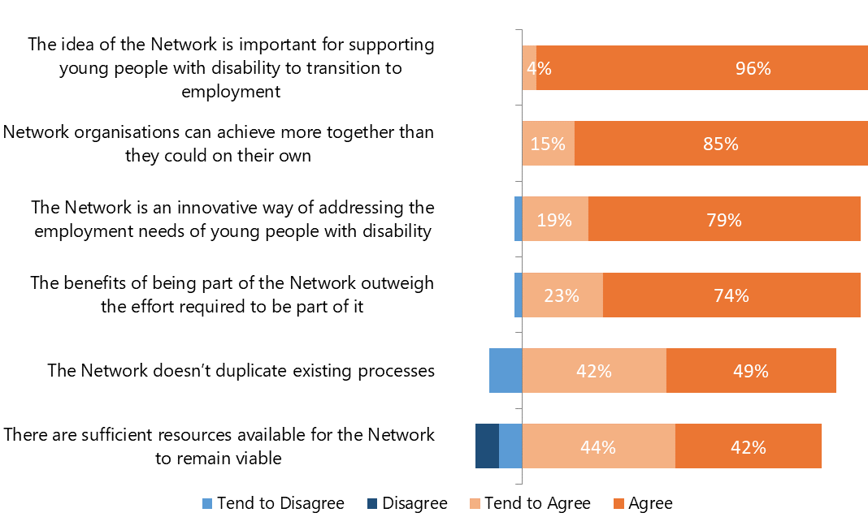
Respondents are extremely satisfied to be a part of a network. Of the 28 comments on the need for partnership, every one praised partnerships as being valuable. Twelve respondents believe partnerships enhance pathway options for young people with disability and lead to better outcomes. Seven respondents also believe the sharing of knowledge, expertise and ideas can help deliver improved processes and initiatives.

The Ticket to Work initiative was a readymade model that galvanised local efforts to enhance pathway options for young people with disability. Ticket to Work allowed us to participate more actively and effectively rather than acting alone.

A network coordinator recognises the benefits that can result from the collection of knowledge, resources and skills through network partnerships:

Within the field of education and employment, there are many organisations/people out there looking to achieve the same thing. By having a partnership approach to achieving goals, this adds weight to ideas, processes and initiatives. Partnerships are also a great way to bring a broad range of expertise around one table.

The following comment addresses concerns surrounding the resources in regard to the sustainability and viability of a Network:

Although the partnerships are with an organisation they tend to be with a person. Therefore, if that person who is passionate about employment outcomes for young people were to leave, a partnership may fall apart.

Partnership Governance
Appropriate partnership governance is vital to the success of the network. While there can be a framework in place the ability to be flexible and constantly update and reflect on working arrangements, responsibilities and maintaining focus on the young person is critical. Figure 2 displays the positive responses to current governance practices.
- Self-reported positivity about the Governance of Partnerships, n=47
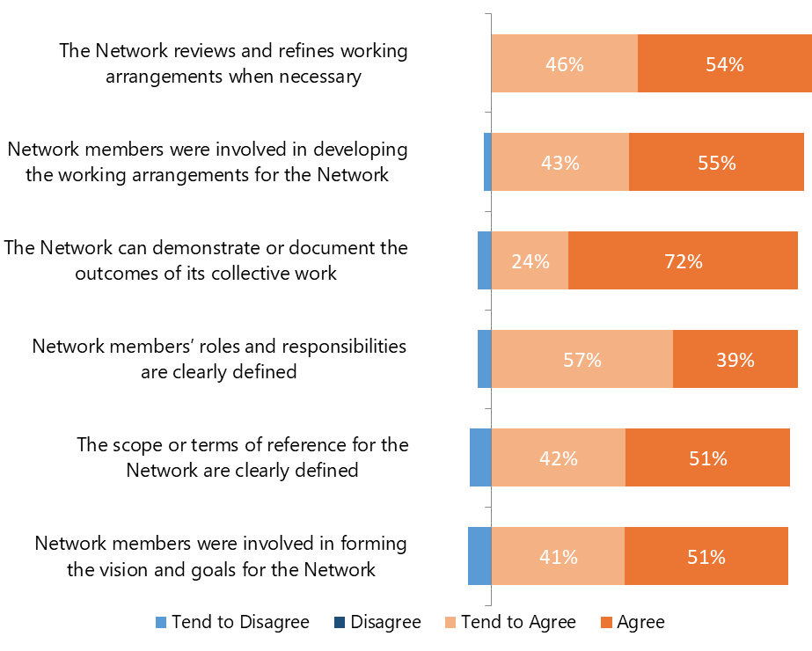
Comments about Partnership Governance outline the importance of all partners in the Network having the same expectations about working arrangements, plans, and procedures and for each individual to “be on the same page”. Four respondents highlight the need for there to be an individual driving the relationship between partners to ensure the success of the partnership. The following comments recognise the need for an individual to lead, organise and clarify roles and responsibilities within the Network:
A clear list of members and organisations and roles within those organisations would be helpful.
Defined by week to week events very flexible, but needs someone to have initiative to go with the flow and manage day to day coordination.
These comments reflect the value of strong management and the following comment begins to address the importance of defining roles to ensure that processes aren’t duplicated and all partners are providing the services and skills they are supposed to provide:
The individual partners are bought in for their specialised service to the students and should be recognised and maintained as that. Partners that come into the network and attempt to be all services in one need to be cautioned to do what they are there to do. This provides the necessary checks and balances so that the programme as a whole is beneficial to students.
Many respondents state that governance should initially be formalised to define roles and responsibilities for members and their organisations, but during the course of the Network developing there should be flexibility and the ability to amend processes.
All members created terms of reference and felt valued in every part of setting up the network.

Respondents have identified that when a Network member changes or new members join; formal governance arrangements should be reviewed and clarified. It may not be unusual for this responsibility to belong to the lead individual or key provider organisation:
As the key provider we are always amending our processes to ensure effective engagement with all parties whilst maintaining compliance.

The Partnership in Action
Partnerships have high reported levels of communication and cooperation between Network members. Partnerships are the most valuable and effective when members communicate and work towards a common goal. Figure 3 indicates the positivity surrounding active partnerships and in particular the coordination of resources, sharing of information and decision making processes.
“It’s been fantastic for the students and the school to have these positive resources. The kids have really embraced Ticket to Work. There is a real value in the students learning and partnership programs achieving their goals. Dovetailing that is very effective”.

- Positive response to the Partnership in Action, n=47
6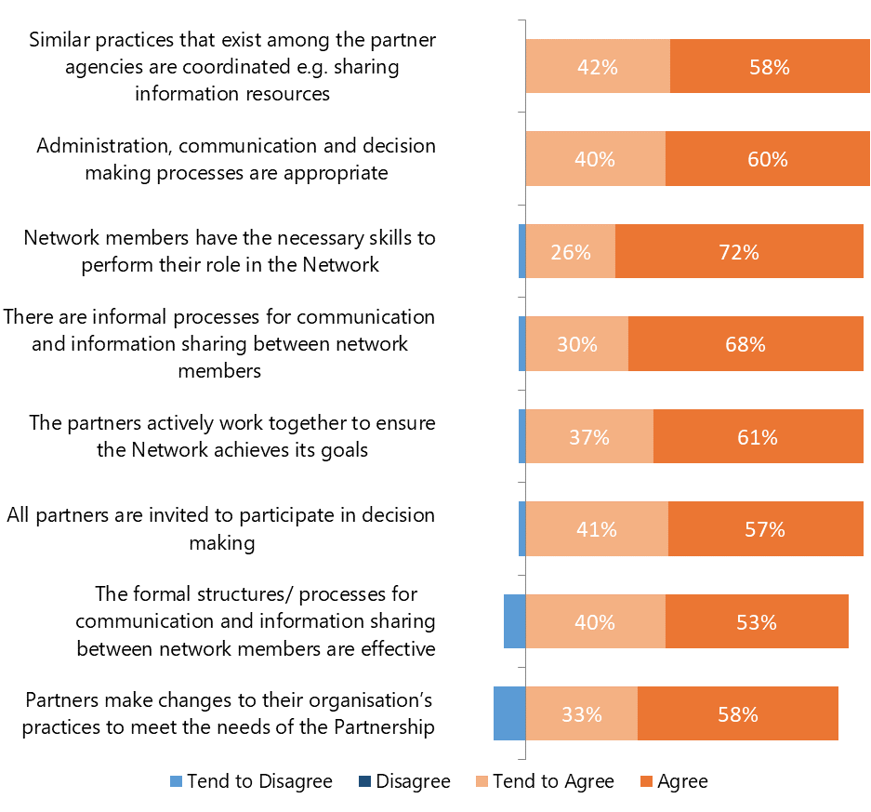
Nine respondents identify that working towards a common goal is the biggest indicator of a partnership being successful. One respondent expresses that:
“Partnerships in action are when people who belong to the network are working
towards a common/the same goal and willing to assist other organisations to achieve
this goal, whether it be through expertise, resources, ideas etc.”.

Four respondents identify the importance and benefits to having regular meetings to drive the process for young people with disability and one of the respondents’ comments highlights this:
“Regular meetings and a constant framework for meetings has made the process flow really well. All activity is focused around the needs of each individual student with weekly follow up. The work preparation component is constantly reviewed and reflected upon after each session, which then leads in to Ticket to Work conversations”.
Partnerships in action have been revealed by network members to be ideal when there are high levels of communication:
“There has been cross over between schools and network members clarifying and understanding needs of students and the workplace”.
“A number of providers have met with potential employers of our students. They have been able to offer different insights into the potential employment of our students. One partner talked about the students, another partner talked about the program that the student would be completing”.

Network Exception: Network 5
Network 5 differs in one question from other Networks in regards to the Partnership in Action element. From the network, 57% of individuals are positive (tend to agree and agree) that the formal structures and processes for communications and information sharing between network members are effective. This contrasts to the 100% positive responses from each other network in regards to this question.
This disparity may stem from the identified lack of formal arrangements when Network members changed:
“A formalised governance arrangement was not clarified when members changed. This is being addressed and it is integral for communication to be clear and reflective of agreed terms”.
“Partners that come into the network and attempts to be all services in one need to be cautioned to do what they are there to do. This provides the necessary checks and balances so that the model as a whole is beneficial to students”.
It is important for all Networks that roles and responsibilities are clearly defined so that members can focus on their strengths and do not duplicate the role of another member or attempt to provide all services themselves. An issue is also raised that organisations should not ask or expect payment from each other as this is “not a business or financial arrangement”.
“Great service using a range of providers in a variety of specialist fields coming together to support young people. When all providers accept others into the network and allow them to do their role without trying to copy that role or do all services themselves then it works extremely well”
“The majority of Network members comprehend the goal of Ticket to Work. At times some network members - RTO's may find it challenging to adapt to students with disability and do not necessarily make effective reasonable adjustments. We recommend the use of Planning 4 Life to assist with tutorial and mentoring through the DAAWS program but not all RTO's are receptive to this recommendation. The use of additional network members and supports strengthens the ability for a young trainee to complete a traineeship to the best of their ability”.

The Impact of the Partnership
Partnerships are reported to provide beneficial services and results to young people with disabilities and result in improved and expanded service delivery from Network members. Respondents acknowledge that working collaboratively allows them to support students in a way that individual organisations cannot. Figure 4 highlights the reported benefits to Network members that in turn have an effect on the prospects for young people with disabilities and the skills, knowledge and abilities of Network members.
- Positive responses to the Impact of the Partnership, n=47
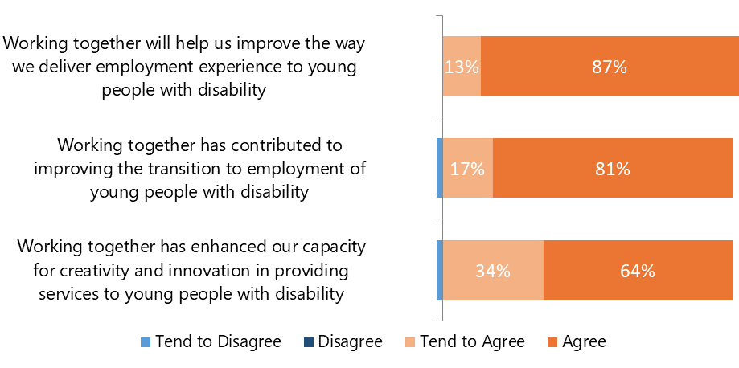
Thirteen respondents identify the positive impact that partnerships have. Four identify that the Network facilitates success and that it provides opportunities above and beyond what an individual organisation could.
One result of the partnership that indicates a broader social and economic impact is that:
Partnership impacts can be very large and positive. As a collective group, you appear larger and more 'serious' when approaching another organisation or an employer about Ticket to Work. Partnerships can also provide opportunities for organisations to expand their local 'footprint' as well as achieve outcomes with assistance.
In essence it is the group efforts that enable our young people to succeed. We have also been able to educate schools and parents about the benefits of Ticket to Work in the process.
Cooperation can bring results that extend further than the reach of an individual organisation.
“As the group develop the Ticket to Work in our area, we have had many positive outcomes for up to a dozen young people. The networking and connections made formally at meetings and via member’s individual work are a strength of the initiative.”
- When the partnership is working well, what is it that seems to make the difference?
Respondents have identified many key components which contribute to the success of the partnership and Ticket to Work model. “Individuals who are passionate about this area and are willing to go above and beyond their role” are highly valued and so are those “working together for the benefits of the young person”.
As a less active member of this network and also a coordinator of another network I have observed the significant difference in evidenced outcomes for students when the school is actively involved and the Employment services are highly active in Ticket to Work. These two elements seem to be key indicators of success.
To support this statement, DES and schools are the two organisations who have both the highest reported and desired level of collaboration from the integration measure responses (Figure 5).
To maintain effective partnerships, it is critical agencies and stakeholders communicate effectively and frequently. “Being on the same page and knowing exactly what their role is within the network” is invaluable and many respondents stress the importance of a collaborative approach. Respondents identify that having a clear understanding of processes, the model and a strong focus on achieving results for young people with disability are invaluable to them.
All members actively provide an extensive amount of support for all students and all members are clear of their role and expectations of each other.
Honest and open communication should make it clear what the responsibilities of each individual and organisation are and they should be allowed to work to their strengths and allow others to do the same without interference from other organisations or individuals. This extends to not duplicating efforts or attempting to perform tasks that are better suited to other individuals and organisations.
Having a lead organisation can clarify who will take responsibility for the effectiveness and management of Ticket to Work. The lead organisation should also act as a facilitator of communication to ensure the appropriate standards are set and that members or intending members are supporting Ticket to Work according to the intention of the Ticket to Work philosophy.
When there is a lead organisation, as there are too many assumptions on who will take responsibility with regards to the effectiveness and management of Ticket to Work. We are also able to set the standards and ensure that intending or participating members are supporting Ticket to Work according to the intention of the Ticket to Work philosophy.
- Unintended results for students or members of the Network
This investigation was interested in seeing what effects respondents reported that were not the core focus of the network from their perspective. These include students outside the network being assisted to find workplace experience and the development of a work readiness course by one organisation.
On four occasions respondents identified that the information they gained about the knowledge, processes and expectations of partners was unexpected but advantageous to themselves and the success of the model.
An unexpected outcome for one organisation was the development of a work readiness course that is “unique in this area”. This organisation and another acknowledge that they have learnt from the students themselves, allowing them to improve their planning about the student and their ability to communicate with students. They have also been better informed when discussing the students with partners leading to increased positivity, expectations and hopes for the student.
Ticket to Work has been identified as a success not only for those within Ticket to Work itself directly as a result of Network partnership efforts. Two respondents identify that students not formally within Ticket to Work received a School Based Apprenticeship and Traineeship or additional outcomes and work placements.
One client has faced challenges in managing DES paperwork compliance as well as servicing Year 11 students according to the guidelines. They also have issues with the categorisation of primary disability as the funding schools receive under EAP as their primary disability may be different to the DES classification. They raise concerns about differences in training within the RTO and that high turnover of RTO staff is disruptive to young people with a disability where sudden changes can impact on the ability to remain focused.
Two respondents identify negative outcomes that are unintended as a result of Ticket to Work. The first is that there was a negative response from schools and families as a result of miscommunication or unrealistic expectations. This highlights the importance of effective communication between partners, schools, students and their families.
Secondly, some partners are identified as working to their own agenda rather than “having the students best interests at heart”. From survey responses about partnerships it is clear that putting the student first and “focussing on the service needs of the client…rather than the needs of the service provider” is important for Ticket to Work to be a success.
- Integration Measures
To get a more precise view on how Ticket to Work networks sit in terms of collaboration with different organisations, network members were asked in the online survey to rate their level of cooperation with other organisations as it is (observed level of cooperation) and as they feel it should be (desired level of cooperation). There were on scale from 0-4 (see methods).
Overall, the observed level of cooperation with other organisations was positioned between ‘2’-Communciation and ‘4’-Collaboriation. The highest levels of observed cooperation are with Disability Employment Services and schools. This indicates strong inter-organisational collaboration compared to collaboration with other services.
Figure 5 shows there is a clear gap (as there usually is) between observed and desired cooperation scores for the sixteen organisations. The observed cooperation score reflects the reported level of cooperation as a positive measure. The desired cooperation score is a normative measure of cooperation accounting for Ticket to Work network members expectations in regards to cooperation with other organisations.
The level of satisfaction compared to the existing level of cooperation – as measured through the gap between observed and desired cooperation – varies between the organisations. The largest disparity between observed and desired cooperation was for employers or employment organisations, transition specialists and apprenticeship centres. The least concern lies with group training and training organisations.
Ticket to Work networks should prioritise increasing network communications with the organisations that have the highest gap between observed and desired levels of collaboration. To highlight the desire for increased communication and interaction with employers, one respondent:
“Would prefer participants be engaged by an employer directly, not through a host employer as this would then mean that the local employer receives the incentives and will have more of a vested interest in keeping the student on post the traineeship”

- Self-reported observed and desired levels of cooperation with other organisations
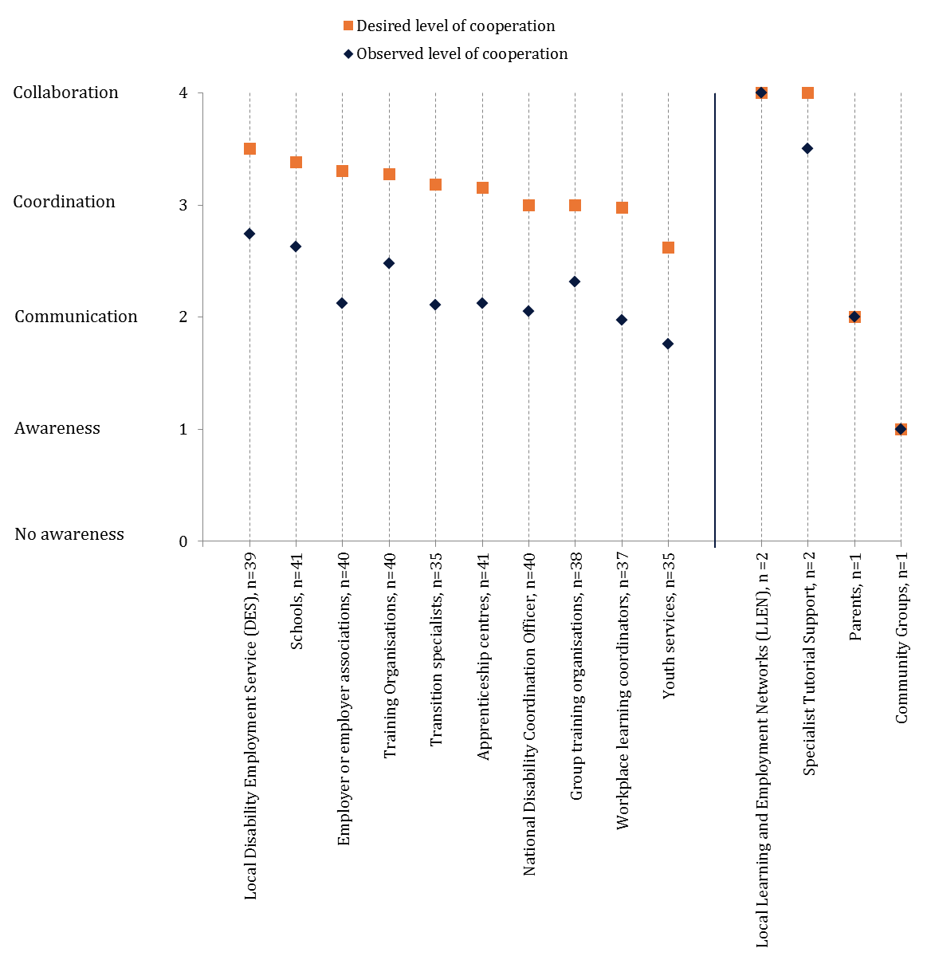
*Source: Ticket to Work online survey, November 2015

